**PRACTICAL NO. 1**

**Configure IP SLA Tracking and Path Control Topology**

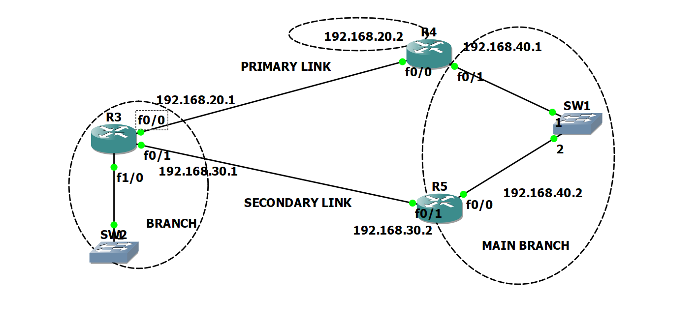

In the topology branch site connected to main site using two link primary and secondary

all the data go through primary link. If the primary link fail then router automatically change the link i.e secondary link. R3 send the icmp echo messages to send packet to R1.

If the R3 will not receive icmp echo response then it will take secondary link on R3 configure.

IP ADDRESS CONFIGURATION –

R1 Commands –

R1#CONF TERM

R1(config)#INT F0/0

R1(config-if)#IP ADDRESS 192.168.20.2 255.255.255.0

R1(config-if)#NO SHUT

R1(config-if)#EXIT

R1(config)#INT F0/1

R1(config-if)#IP ADDRESS 192.168.40.1 255.255.255.0

R1(config-if)#NO SHUT

R1(config-if)#EXIT

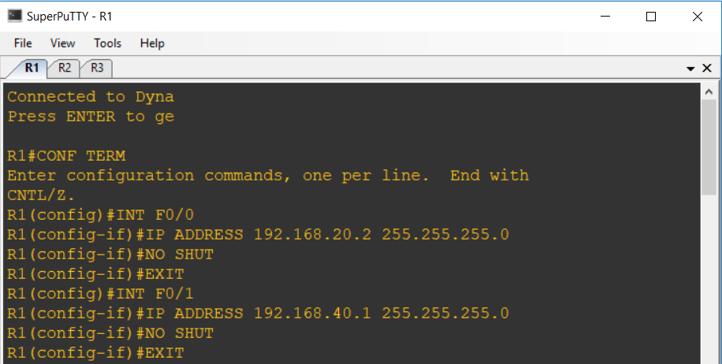

R2 COMMANDS –

R2#CONF TERM

R2(config)#INT F0/1

R2(config-if)#IP ADDRESS 192.168.30.2 255.255.255.0

R2(config-if)#NO SHUT

R2(config-if)#EXIT

R2(config)#INT F0/0

R2(config-if)#IP ADDRESS 192.168.40.2 255.255.255.0

R2(config-if)#NO SHUT

R2(config-if)#EXIT

R3 COMMANDS –

R3#CONF TERM

R3(config)#INT F0/0

R3(config-if)#IP ADDRESS 192.168.20.1 255.255.255.0

R3(config-if)#NO SHUT

R3(config-if)#EXIT

R3(config)#INT F0/1

R3(config-if)#IP ADDRESS 192.168.30.1 255.255.255.0

R3(config-if)#NO SHUT

R3(config-if)#EXIT

STATIC ROUTING –

R3(config)#IP ROUTE 192.168.40.0 255.255.255.0 192.168.20.2

R3(config)#IP ROUTE 192.168.40.0 255.255.255.0 192.168.30.2

R3(config)#EXIT

R3#SHOW IP ROUTE

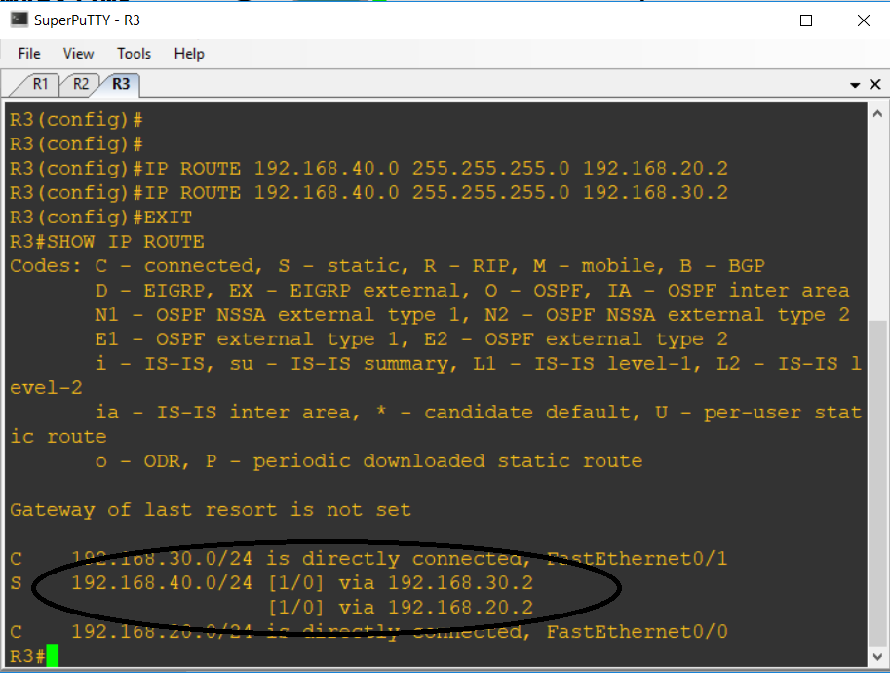

IP SLA Commands –

R3#CONF TERM

R3(config)#IP SLA 1

R3(config-ip-sla)#ICMP-ECHO 192.168.20.2 SOURCE-INTERFACE F0/0

R3(config-ip-sla-echo)#FREQUENCY 10

R3(config-ip-sla-echo)#TIMEOUT 6000

R3(config-ip-sla-echo)#EXIT

R3(config)#IP SLA SCHEDULE 1 START-TIME NOW LIFE FOREVER

The operation number of 1 is only locally significant to the router. The **frequency 10** command schedules the connectivity test to repeat every 10 seconds. The probe is scheduled to start now and to run forever. Verify the IP SLAs configuration of operation 1 using the **show ip sla configuration 1** command.

R1# **show ip sla configuration 1**

**Configure tracking options.**

Although PBR could be used, you will configure a floating static route that appears or disappears depending on the success or failure of the IP SLA.

R3(config)#TRACK 10 IP ROUTE 192.168.40.0 255.255.255.0 REACHABILITY

R3(config-track)#EXIT

Use the show track command to check the track configuration. you will get reachability up output in this command –

R3#SHOW TRACK

Track 10

IP route 192.168.40.0 255.255.255.0 reachability

Reachability is Up (static)

1 change, last change 00:01:53

First-hop interface is FastEthernet0/0

R3#

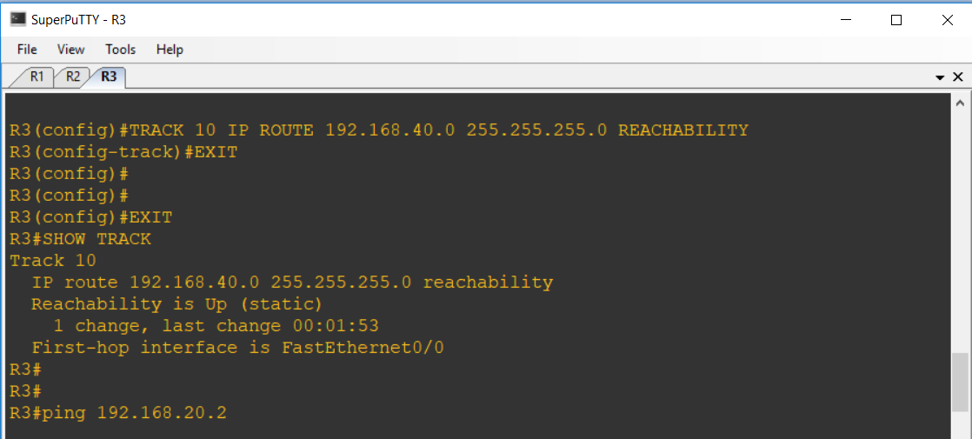

Again configure the static route for ip sla with your track configuration.

R3(config)#IP ROUTE 192.168.40.0 255.255.255.0 192.168.20.2 TRACK 10

R3(config)#IP ROUTE 192.168.40.0 255.255.255.0 192.168.30.2 5

R3(config)#EXIT

R3#

R3#SHOW IP ROUTE

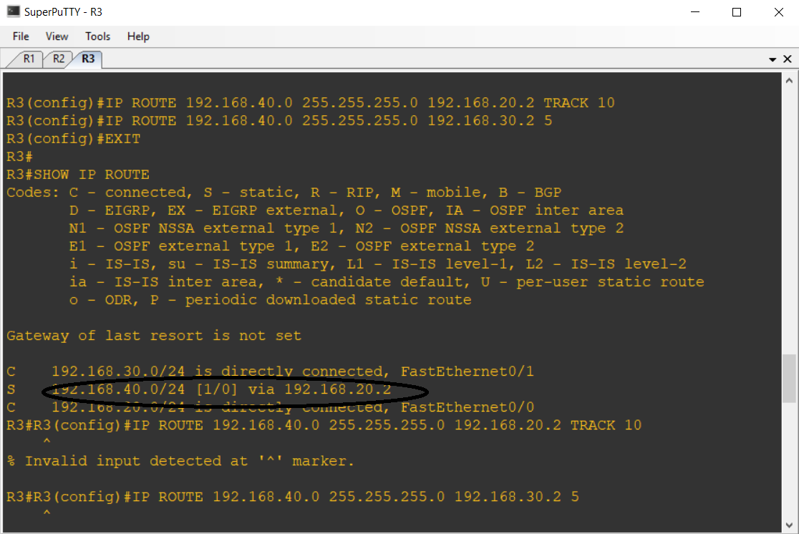

In this final configuration we will get only one link to reach to network 192.168.40.0 as per ip sla created on network.

**Practical No.2**

**Using the AS_PATH Attribute**

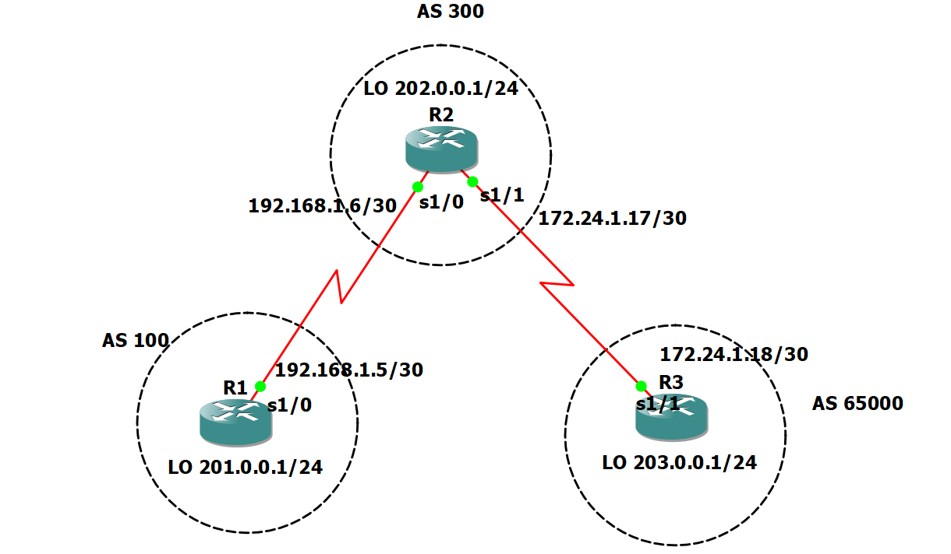

In this lab, the student will use BGP commands to prevent private AS numbers from being advertised

to the outside world. The student will also use the AS_PATH attribute to filter BGP routes based on

their source AS numbers.

**Scenario**

The International Travel Agency’s Internet service provider ISP2 has been assigned an AS number

of 300. This provider uses BGP to exchange routing information with several customer networks.

Each customer network is assigned an AS number from the private range, such as AS 65000.

Configure ISP2 to remove the private AS numbers within the AS_Path information from the CusRtr.

In addition, Provider ISP2 would like to prevent its customer networks from receiving route

information from International Travel Agency’s AS 100. Use the AS_PATH attribute to implement this policy.

IP ADDRESS CONFIGURATION –

R1 Commands –

R1#Conf Term

R1(config)#INT S1/0

R1(config-if)#NO IP ADDRESS

R1(config-if)#IP ADDRESS 192.168.1.5 255.255.255.252

R1(config-if)#NO SHUT

R1(config-if)#EXIT

R1(config)#INT LO0

R1(config-if)#IP ADDRESS 201.0.0.1 255.255.255.0

R1(config-if)#NO SHUT

R1(config-if)#EXIT

R2 COMMANDS –

R2#CONF TERM

R2(config)#INT S1/0

R2(config-if)#IP ADDRESS 192.168.1.6 255.255.255.252

R2(config-if)#NO SHUT

R2(config-if)#EXIT

R2(config)#INT S1/1

R2(config-if)#IP ADDRESS 172.24.1.17 255.255.255.252

R2(config-if)#NO SHUT

R2(config-if)#EXIT

R2(config)#INT LO0

R2(config-if)#IP ADDRESS 202.0.0.1 255.255.255.0

R2(config-if)#NO SHUT

R2(config-if)#EXIT

R3 COMMANDS –

R3#CONF TERM

R3(config)#INT S1/1

R3(config-if)#IP ADDRESS 172.24.1.18 255.255.255.252

R3(config-if)#NO SHUT

R3(config-if)#EXIT

R3(config)#

R3(config)#INT LO0

R3(config-if)#IP ADDRESS 203.0.0.1 255.255.255.0

R3(config-if)#NO SHUT

R3(config-if)#EXIT

Build and configure the network according to the diagram, but do not configure a routing protocol.

Use **ping** to test connectivity between the directly connected routers.

Configure BGP for normal operation. Enter the appropriate BGP commands on each router so that

they will identify their BGP neighbors and advertise their Ethernet networks –

R1 (config)#**router bgp 100**

R1 (config-router)#**no synchronization**

R1 (config-router)#**neighbor 192.168.1.6 remote-as 300**

R1 (config-router)#**network 201.0.0.0**

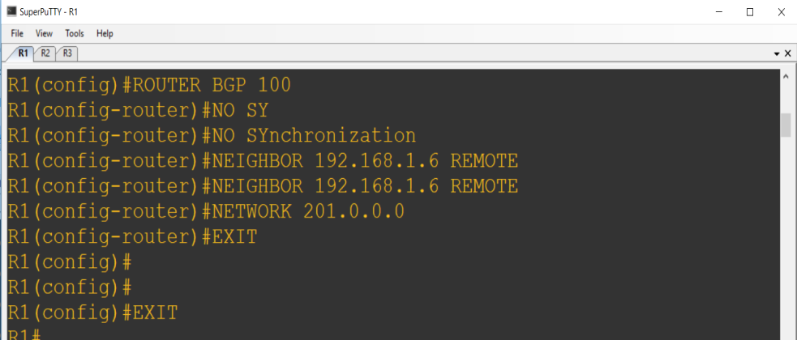

R2 (config)#**router bgp 300**

R2(config-router)#**no synchronization**

R2 (config-router)#**neighbor 192.168.1.5 remote-as 100**

R2 (config-router)#**neighbor 172.24.1.18 remote-as 65000**

R2 (config-router)#**network 202.0.0.0**

R3 (config)#**router bgp 65000**

R3 (config-router)#**no synchronization**

R3 (config-router)#**neighbor 172.24.1.17 remote-as 300**

R3 (config-router)#**network 203.0.0.0**

Verify that these routers have established the appropriate neighbor relationships by issuing the

**Show ip bgp neighbors** command at each router.

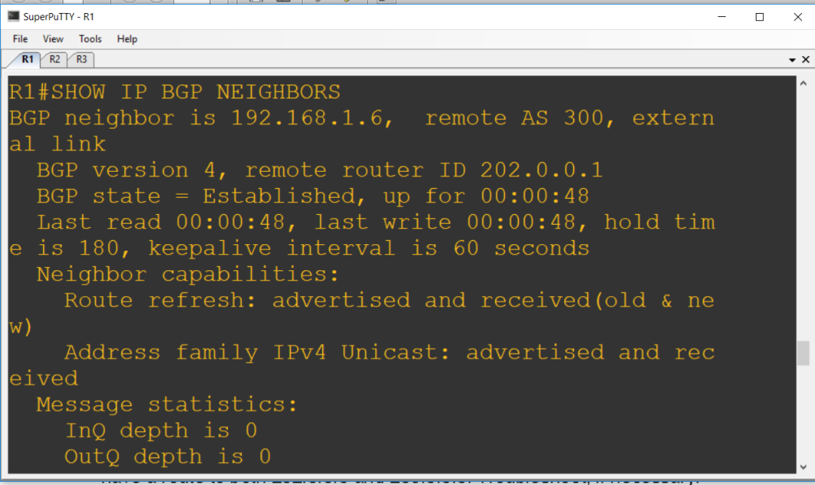

Check the routing table from R1 by using the **show ip route** command. R1 should have a route to both 202.0.0.0 and 203.0.0.0.

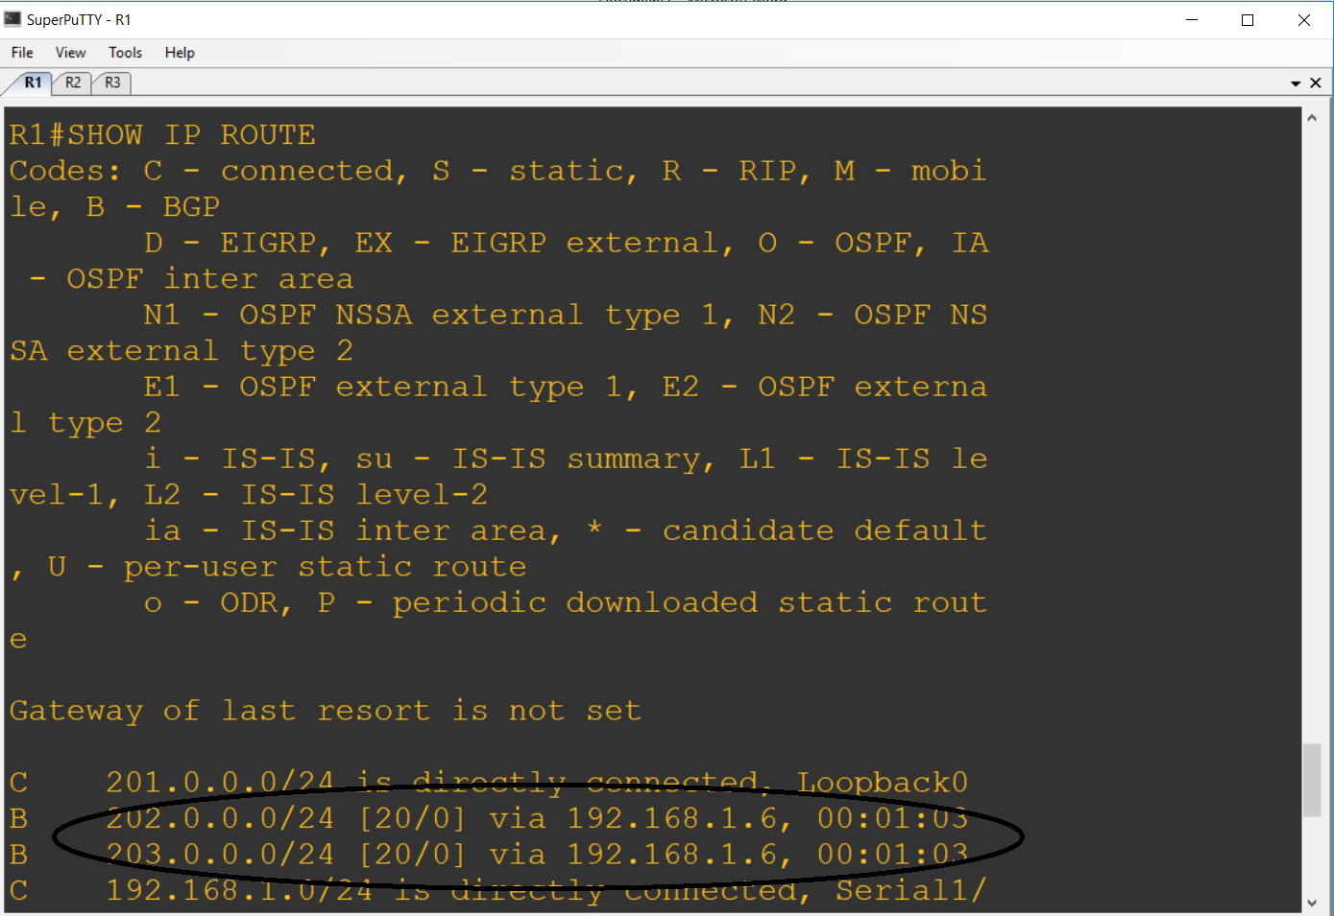

Check the BGP table from R1 by using the **show ip bgp** command. Note the AS path for the 203.0.0.0 network. The AS 65000 should be listed in the path to 203.0.0.0.

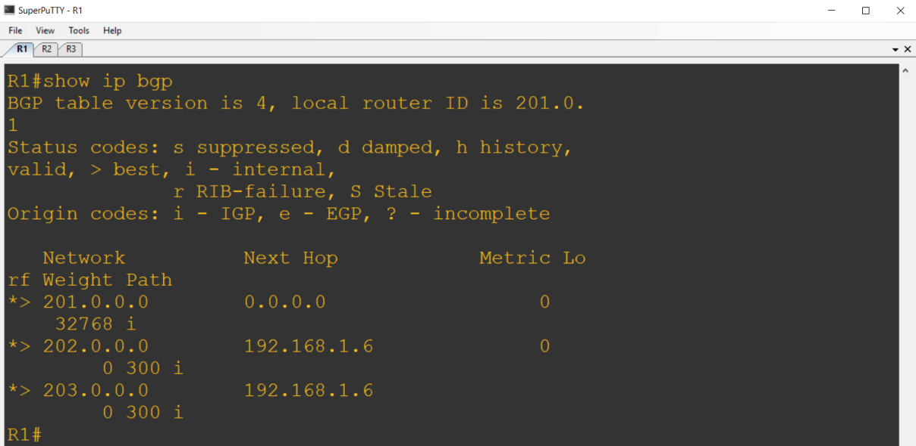

Configure R2 to strip the private AS numbers from BGP routes exchanged with R1. Use the

following commands:

R2(config)#**router bgp 300**

R2(config-router)#**neighbor 192.168.1.5 remove-private-as**

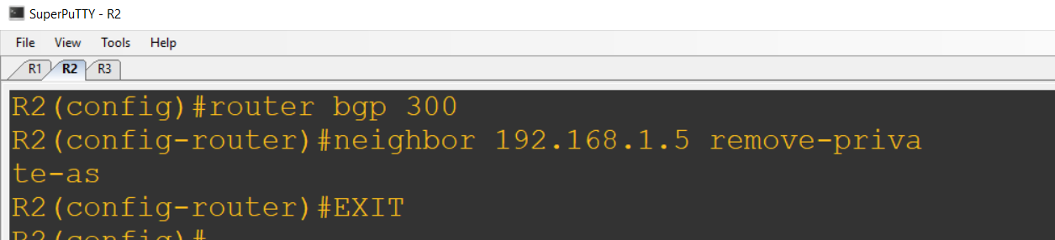

After issuing these commands, use the **clear ip bgp \*** command on R1 to re-establish

the BGP relationships between the three routers.

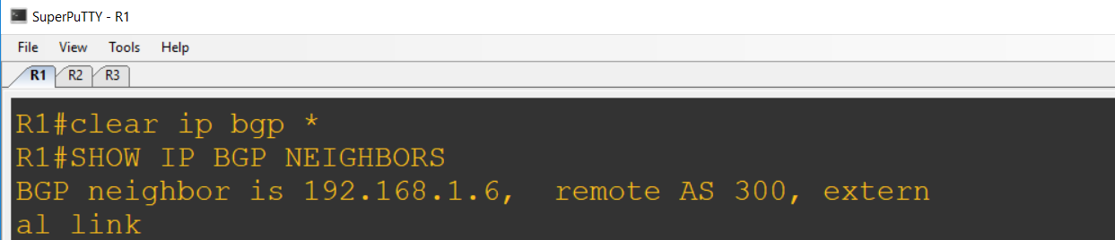

Wait several seconds, and then return to R1 to check its routing table.

R1 should be able to ping 203.0.0.0.

Now check the BGP table on R1. The AS_PATH to the 203.0.0.0 network should be AS 300.

As a final configuration, use the AS_PATH attribute to filter routes based on their origin. In a complex environment, this attribute can be used to enforce routing policy. In this case, the provider router R2, must be configured so that it does not propagate routes that originate from AS 100 to the

customer router, R3.

First, configure a special kind of access list to match BGP routes with an AS_PATH attribute that

both begins and ends with the number 100. Enter the following commands on R2:

R2(config)#**ip as-path access-list 1 deny ^100$**

R2(config)#**ip as-path access-list 1 permit .\***

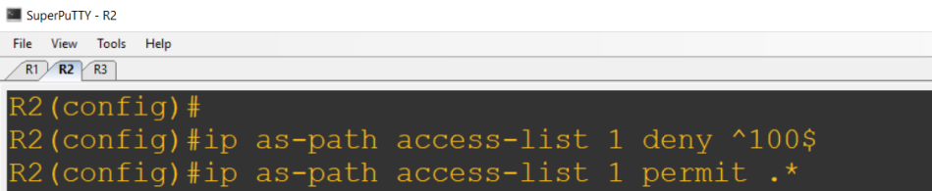

Now that the access list has been configured, apply it as follows:

R2(config)#**router bgp 300**

R2(config-router)#**neighbor 172.24.1.18 filter-list 1 out**

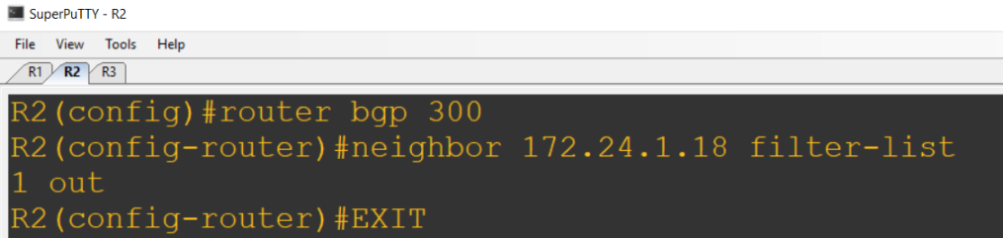

The **out** keyword specifies that the list should be applied to routing information sent to this neighbor.

Use the **clear ip bgp \*** command to reset the routing information. Wait several seconds, and

then check the routing table for R2. The route to 201.0.0.0 should be in the routing table.

Check the routing table for R3. It should not have a route to 201.0.0.0 in its routing table.

Return to R2 and verify that the filter is working as intended. Issue the command **show ip bgp**

**regexp ^100$**.

The output of this command shows all matches for the regular expressions that were used in the

access list. The path to 201.0.0.0 matches the access list and is filtered out of updates to R3.

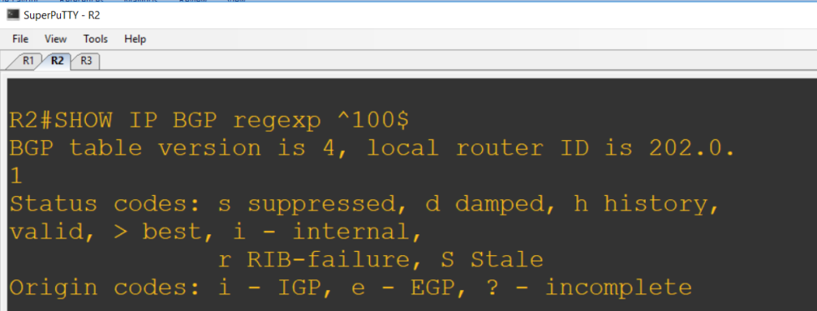

**Practical No. 3**

**Configuring IBGP and EBGP Sessions, Local Preference, and MED**

**Topology**

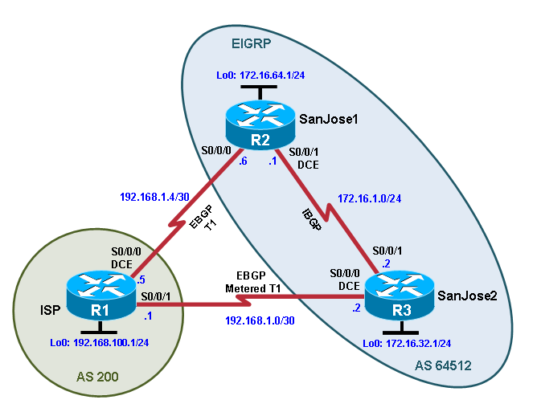

**Objectives**

* For IBGP peers to correctly exchange routing information, use the **next-hop-self** command with the **Local-Preference** and **MED** attributes.
* Ensure that the flat-rate, unlimited-use T1 link is used for sending and receiving data to and from the AS 200 on ISP and that the metered T1 only be used in the event that the primary T1 link has failed.

**Background**

The International Travel Agency runs BGP on its SanJose1 and SanJose2 routers externally with the ISP router in AS 200. IBGP is run internally between SanJose1 and SanJose2. Your job is to configure both EBGP and IBGP for this internetwork to allow for redundancy. The metered T1 should only be used in the event that the primary T1 link has failed. Traffic sent across the metered T1 link offers the same bandwidth of the primary link but at a huge expense. Ensure that this link is not used unnecessarily.

**Required Resources**

* 3 routers (Cisco IOS Release 15.2 or comparable)
* Serial and Ethernet cables

**Step 0: Suggested starting configurations.**

1. Apply the following configuration to each router along with the appropriate **hostname**. The **exec-timeout 0 0** command should only be used in a lab environment.

Router(config)# **no ip domain-lookup**

Router(config)# **line con 0**

Router(config-line)# **logging synchronous**

Router(config-line)# **exec-timeout 0 0**

**Step 1: Configure interface addresses.**

1. Using the addressing scheme in the diagram, create the loopback interfaces and apply IPv4 addresses to these and the serial interfaces on ISP (R1), SanJose1 (R2), and SanJose2 (R3).

**Router R1 (hostname ISP)**

ISP(config)# **interface Loopback0**

ISP(config-if)# **ip address 192.168.100.1 255.255.255.0**

ISP(config-if)# **exit**

ISP(config)# **interface Serial0/0/0**

ISP(config-if)# **ip address 192.168.1.5 255.255.255.252**

ISP(config-if)# **clock rate 128000**

ISP(config-if)# **no shutdown**

ISP(config-if)# **exit**

ISP(config)# **interface Serial0/0/1**

ISP(config-if)# **ip address 192.168.1.1 255.255.255.252**

ISP(config-if)# **no shutdown**

ISP(config-if)# **end**

ISP#

**Router R2 (hostname SanJose1)**

SanJose1(config)# **interface Loopback0**

SanJose1(config-if)# **ip address 172.16.64.1 255.255.255.0**

SanJose1(config-if)# **exit**

SanJose1(config)# **interface Serial0/0/0**

SanJose1(config-if)# **ip address 192.168.1.6 255.255.255.252**

SanJose1(config-if)# **no shutdown**

SanJose1(config-if)# **exit**

SanJose1(config)# **interface Serial0/0/1**

SanJose1(config-if)# **ip address 172.16.1.1 255.255.255.0**

SanJose1(config-if)# **clock rate 128000**

SanJose1(config-if)# **no shutdown**

SanJose1(config-if)# **end**

SanJose1#

**Router R3 (hostname SanJose2)**

SanJose2(config)# **interface Loopback0**

SanJose2(config-if)# **ip address 172.16.32.1 255.255.255.0**

SanJose2(config-if)# **exit**

SanJose2(config)# **interface Serial0/0/0**

SanJose2(config-if)# **ip address 192.168.1.2 255.255.255.252**

SanJose2(config-if)# **clock rate 128000**

SanJose2(config-if)# **no shutdown**

SanJose2(config-if)# **exit**

SanJose2(config)# **interface Serial0/0/1**

SanJose2(config-if)# **ip address 172.16.1.2 255.255.255.0**

SanJose2(config-if)# **no shutdown**

SanJose2(config-if)# **end**

SanJose2#

1. Use **ping** to test the connectivity between the directly connected routers. Both SanJose routers should be able to ping each other and their local ISP serial link IP address. The ISP router cannot reach the segment between SanJose1 and SanJose2.

**Step 2: Configure EIGRP.**

Configure EIGRP between the SanJose1 and SanJose2 routers. (Note: If using an IOS prior to 15.0, use the no auto-summary router configuration command to disable automatic summarization. This command is the default beginning with IOS 15.)

SanJose1(config)# **router eigrp 1**

SanJose1(config-router)# **network 172.16.0.0**

SanJose2(config)# **router eigrp 1**

SanJose2(config-router)# **network 172.16.0.0**

**Step 3: Configure IBGP and verify BGP neighbors.**

1. Configure IBGP between the SanJose1 and SanJose2 routers. On the SanJose1 router, enter the following configuration.

SanJose1(config)# **router bgp 64512**

SanJose1(config-router)# **neighbor 172.16.32.1 remote-as 64512**

SanJose1(config-router)# **neighbor 172.16.32.1 update-source lo0**

If multiple pathways to the BGP neighbor exist, the router can use multiple IP interfaces to communicate with the neighbor. The source IP address therefore depends on the outgoing interface. The **update-source lo0** command instructs the router to use the IP address of the interface Loopback0 as the source IP address for all BGP messages sent to that neighbor.

1. Complete the IBGP configuration on SanJose2 using the following commands.

SanJose2(config)# **router bgp 64512**

SanJose2(config-router)# **neighbor 172.16.64.1 remote-as 64512**

SanJose2(config-router)# **neighbor 172.16.64.1 update-source lo0**

1. Verify that SanJose1 and SanJose2 become BGP neighbors by issuing the **show ip bgp neighbors** command on SanJose1. View the following partial output. If the BGP state is not established, troubleshoot the connection.

SanJose2# **show ip bgp neighbors**

BGP neighbor is 172.16.64.1, remote AS 64512, internal link

BGP version 4, remote router ID 172.16.64.1

BGP state = Established, up for 00:00:22

Last read 00:00:22, last write 00:00:22, hold time is 180, keepalive interval is 60 seconds

<output omitted>

The link between SanJose1 and SanJose2 should be identified as an internal link indicating an IBGP peering relationship, as shown in the output.

**Step 4: Configure EBGP and verify BGP neighbors.**

1. Configure ISP to run EBGP with SanJose1 and SanJose2. Enter the following commands on ISP.

ISP(config)# **router bgp 200**

ISP(config-router)# **neighbor 192.168.1.6 remote-as 64512**

ISP(config-router)# **neighbor 192.168.1.2 remote-as 64512**

ISP(config-router)# **network 192.168.100.0**

Because EBGP sessions are almost always established over point-to-point links, there is no reason to use the **update-source** keyword in this configuration. Only one path exists between the peers. If this path goes down, alternative paths are not available.

1. Configure a discard static route for the 172.16.0.0/16 network. Any packets that do not have a more specific match (longer match) for a 172.16.0.0 subnet will be dropped instead of sent to the ISP. Later in this lab we will configure a default route to the ISP.

SanJose1(config)# **ip route 172.16.0.0 255.255.0.0 null0**

1. Configure SanJose1 as an EBGP peer to ISP.

SanJose1(config)# **router bgp 64512**

SanJose1(config-router)# **neighbor 192.168.1.5 remote-as 200**

SanJose1(config-router)# **network 172.16.0.0**

1. Use the **show ip bgp neighbors** command to verify that SanJose1 and ISP have reached the established state. Troubleshoot if necessary.

SanJose1# **show ip bgp neighbors**

BGP neighbor is 172.16.32.1, remote AS 64512, internal link

BGP version 4, remote router ID 172.16.32.1

BGP state = Established, up for 00:12:43

<output omitted>

BGP neighbor is 192.168.1.5, remote AS 200, external link

BGP version 4, remote router ID 192.168.100.1

BGP state = Established, up for 00:06:49

Last read 00:00:42, last write 00:00:45, hold time is 180, keepalive interval is 60 seconds

<output omitted>

Notice that the “external link” indicates that an EBGP peering session has been established. You should also see an informational message indicating the establishment of the BGP neighbor relationship.

*Sep 8 21:09:59.699: %BGP-5-ADJCHANGE: neighbor 192.168.1.5 Up

1. Configure a discard static route for 172.16.0.0/16 on SanJose2 and as an EBGP peer to ISP.

SanJose2(config)# **ip route 172.16.0.0 255.255.0.0 null0**

SanJose2(config)# **router bgp 64512**

SanJose2(config-router)# **neighbor 192.168.1.1 remote-as 200**

SanJose2(config-router)# **network 172.16.0.0**

**Step 5: View BGP summary output.**

In Step 4, the **show ip bgp neighbors** command was used to verify that SanJose1 and ISP had reached the established state. A useful alternative command is **show ip bgp summary**. The output should be similar to the following.

SanJose2# **show ip bgp summary**

BGP router identifier 172.16.32.1, local AS number 64512

BGP table version is 6, main routing table version 6

2 network entries using 288 bytes of memory

4 path entries using 320 bytes of memory

4/2 BGP path/bestpath attribute entries using 640 bytes of memory

1 BGP AS-PATH entries using 24 bytes of memory

0 BGP route-map cache entries using 0 bytes of memory

0 BGP filter-list cache entries using 0 bytes of memory

BGP using 1272 total bytes of memory

BGP activity 2/0 prefixes, 4/0 paths, scan interval 60 secs

Neighbor V AS MsgRcvd MsgSent TblVer InQ OutQ Up/Down State/PfxRcd

172.16.64.1 4 64512 27 26 6 0 0 00:18:15 2

192.168.1.1 4 200 10 7 6 0 0 00:01:42 1

SanJose2#

**Step 6: Verify which path the traffic takes.**

1. Clear the IP BGP conversation with the **clear ip bgp \*** command on ISP. Wait for the conversations to reestablish with each SanJose router.

ISP# **clear ip bgp \***

ISP#

*Nov 9 22:05:32.427: %BGP-5-ADJCHANGE: neighbor 192.168.1.2 Down User reset

*Nov 9 22:05:32.427: %BGP_SESSION-5-ADJCHANGE: neighbor 192.168.1.2 IPv4 Unicast topology base removed from session User reset

*Nov 9 22:05:32.427: %BGP-5-ADJCHANGE: neighbor 192.168.1.6 Down User reset

*Nov 9 22:05:32.427: %BGP_SESSION-5-ADJCHANGE: neighbor 192.168.1.6 IPv4 Unicast topology base removed from session User reset

*Nov 9 22:05:32.851: %BGP-5-ADJCHANGE: neighbor 192.168.1.2 Up

*Nov 9 22:05:32.851: %BGP-

ISP#5-ADJCHANGE: neighbor 192.168.1.6 Up

ISP#

1. Test whether ISP can ping the loopback 0 address of 172.16.64.1 on SanJose1 and the serial link between SanJose1 and SanJose2, 172.16.1.1.

ISP# **ping 172.16.64.1**

Type escape sequence to abort.

Sending 5, 100-byte ICMP Echos to 172.16.64.1, timeout is 2 seconds:

.....

Success rate is 0 percent (0/5)

ISP#

ISP# **ping 172.16.1.1**

Type escape sequence to abort.

Sending 5, 100-byte ICMP Echos to 172.16.1.1, timeout is 2 seconds:

.....

Success rate is 0 percent (0/5)

ISP#

1. Now ping from ISP to the loopback 0 address of 172.16.32.1 on SanJose2 and the serial link between SanJose1 and SanJose2, 172.16.1.2.

ISP# **ping 172.16.32.1**

Type escape sequence to abort.

Sending 5, 100-byte ICMP Echos to 172.16.32.1, timeout is 2 seconds:

!!!!!

Success rate is 100 percent (5/5), round-trip min/avg/max = 12/14/16 ms

ISP# **ping 172.16.1.2**

Type escape sequence to abort.

Sending 5, 100-byte ICMP Echos to 172.16.1.2, timeout is 2 seconds:

!!!!!

Success rate is 100 percent (5/5), round-trip min/avg/max = 12/13/16 ms

ISP#

You should see successful pings to each IP address on SanJose2 router. Ping attempts to 172.16.64.1 and 172.16.1.1 should fail. Why does this happen?

1. Issue the **show ip bgp** command on ISP to verify BGP routes and metrics.

ISP# **show ip bgp**

BGP table version is 3, local router ID is 192.168.100.1

Status codes: s suppressed, d damped, h history, * valid, > best, i - internal,

r RIB-failure, S Stale, m multipath, b backup-path, f RT-Filter,

x best-external, a additional-path, c RIB-compressed,

Origin codes: i - IGP, e - EGP, ? - incomplete

RPKI validation codes: V valid, I invalid, N Not found

Network Next Hop Metric LocPrf Weight Path

* 172.16.0.0 192.168.1.6 0 0 64512 i

*> 192.168.1.2 0 0 64512 i

*> 192.168.100.0 0.0.0.0 0 32768 i

ISP#

ISP# **show ip bgp**

Notice that ISP has two valid routes to the 172.16.0.0 network, as indicated by the **.** However, the link to SanJose2 has been selected as the best path, indicated by the inclusion of the “>”. Why did the ISP prefer the link to SanJose2 over SanJose1?

Would changing the bandwidth metric on each link help to correct this issue? Explain.

BGP operates differently than all other protocols. Unlike other routing protocols that use complex algorithms involving factors such as bandwidth, delay, reliability, and load to formulate a metric, BGP is policy-based. BGP determines the best path based on variables, such as AS path, weight, local preference, MED, and so on. If all things are equal, BGP prefers the route leading to the BGP speaker with the lowest BGP router ID. The SanJose2 router with BGP router ID 172.16.32.1 was preferred to the higher BGP router ID of the SanJose1 router (172.16.64.1).

1. At this point, the ISP router should be able to get to each network connected to SanJose1 and SanJose2 from the loopback address 192.168.100.1. Use the extended **ping** command and specify the source address of ISP Lo0 to test.

ISP# **ping 172.16.1.1 source 192.168.100.1**

Type escape sequence to abort.

Sending 5, 100-byte ICMP Echos to 172.16.1.1, timeout is 2 seconds:

Packet sent with a source address of 192.168.100.1

!!!!!

Success rate is 100 percent (5/5), round-trip min/avg/max = 20/21/24 ms

ISP# **ping 172.16.32.1 source 192.168.100.1**

Type escape sequence to abort.

Sending 5, 100-byte ICMP Echos to 172.16.32.1, timeout is 2 seconds:

Packet sent with a source address of 192.168.100.1

!!!!!

Success rate is 100 percent (5/5), round-trip min/avg/max = 12/15/16 ms

ISP# **ping 172.16.1.2 source 192.168.100.1**

Type escape sequence to abort.

Sending 5, 100-byte ICMP Echos to 172.16.1.2, timeout is 2 seconds:

Packet sent with a source address of 192.168.100.1

!!!!!

Success rate is 100 percent (5/5), round-trip min/avg/max = 12/15/16 ms

ISP#

ISP# **ping 172.16.64.1 source 192.168.100.1**

Type escape sequence to abort.

Sending 5, 100-byte ICMP Echos to 172.16.64.1, timeout is 2 seconds:

Packet sent with a source address of 192.168.100.1

!!!!!

Success rate is 100 percent (5/5), round-trip min/avg/max = 20/21/24 ms

Complete reachability has been demonstrated between the ISP router and both SanJose1 and SanJose2.

**Step 7: Configure the BGP next-hop-self feature.**

SanJose1 is unaware of the link between ISP and SanJose2, and SanJose2 is unaware of the link between ISP and SanJose1. Before ISP can successfully ping all the internal serial interfaces of AS 64512, these serial links should be advertised via BGP on the ISP router. This can also be resolved via EIGRP on each SanJose router. One method is for ISP to advertise these links.

1. Issue the following commands on the ISP router.

ISP(config)# **router bgp 200**

ISP(config-router)# **network 192.168.1.0 mask 255.255.255.252**

ISP(config-router)# **network 192.168.1.4 mask 255.255.255.252**

1. Issue the **show ip bgp** command to verify that the ISP is correctly injecting its own WAN links into BGP.

ISP# **show ip bgp**

BGP table version is 5, local router ID is 192.168.100.1

Status codes: s suppressed, d damped, h history, * valid, > best, i - internal,

r RIB-failure, S Stale, m multipath, b backup-path, f RT-Filter,

x best-external, a additional-path, c RIB-compressed,

Origin codes: i - IGP, e - EGP, ? - incomplete

RPKI validation codes: V valid, I invalid, N Not found

Network Next Hop Metric LocPrf Weight Path

* 172.16.0.0 192.168.1.6 0 0 64512 i

*> 192.168.1.2 0 0 64512 i

*> 192.168.1.0/30 0.0.0.0 0 32768 i

*> 192.168.1.4/30 0.0.0.0 0 32768 i

*> 192.168.100.0 0.0.0.0 0 32768 i

1. Verify on SanJose1 and SanJose2 that the opposite WAN link is included in the routing table. The output from SanJose2 is as follows.

SanJose2# **show ip route**

Codes: L - local, C - connected, S - static, R - RIP, M - mobile, B - BGP

D - EIGRP, EX - EIGRP external, O - OSPF, IA - OSPF inter area

N1 - OSPF NSSA external type 1, N2 - OSPF NSSA external type 2

E1 - OSPF external type 1, E2 - OSPF external type 2

i - IS-IS, su - IS-IS summary, L1 - IS-IS level-1, L2 - IS-IS level-2

ia - IS-IS inter area, * - candidate default, U - per-user static route

o - ODR, P - periodic downloaded static route, H - NHRP, l - LISP

a - application route

+ - replicated route, % - next hop override

Gateway of last resort is not set

172.16.0.0/16 is variably subnetted, 6 subnets, 3 masks

S 172.16.0.0/16 is directly connected, Null0

C 172.16.1.0/24 is directly connected, Serial0/0/1

L 172.16.1.2/32 is directly connected, Serial0/0/1

C 172.16.32.0/24 is directly connected, Loopback0

L 172.16.32.1/32 is directly connected, Loopback0

D 172.16.64.0/24 [90/2297856] via 172.16.1.1, 00:52:03, Serial0/0/1

192.168.1.0/24 is variably subnetted, 3 subnets, 2 masks

C 192.168.1.0/30 is directly connected, Serial0/0/0

L 192.168.1.2/32 is directly connected, Serial0/0/0

B 192.168.1.4/30 [20/0] via 192.168.1.1, 00:01:03

B 192.168.100.0/24 [20/0] via 192.168.1.1, 00:25:20

The next issue to consider is BGP policy routing between autonomous systems. The next-hop attribute of a route in a different AS is set to the IP address of the border router in the next AS toward the destination, and this attribute is not modified by default when advertising this route through IBGP. Therefore, for all IBGP peers, it is either necessary to know the route to that border router (in a different neighboring AS), or our own border router needs to advertise the foreign routes using the next-hop-self feature, overriding the next-hop address with its own IP address. The SanJose2 router is passing a policy to SanJose1 and vice versa. The policy for routing from AS 64512 to AS 200 is to forward packets to the 192.168.1.1 interface. SanJose1 has a similar yet opposite policy: it forwards requests to the 192.168.1.5 interface. If either WAN link fails, it is critical that the opposite router become a valid gateway. This is achieved if the **next-hop-self** command is configured on SanJose1 and SanJose2.

1. To better understand the **next-hop-self** command we will remove ISP advertising its two WAN links and shutdown the WAN link between ISP and SanJose2. The only possible path from SanJose2 to ISP’s 192.168.100.0/24 is through SanJose1.

ISP(config)# **router bgp 200**

ISP(config-router)# **no** **network 192.168.1.0 mask 255.255.255.252**

ISP(config-router)# **no** **network 192.168.1.4 mask 255.255.255.252**

ISP(config-router)# **exit**

ISP(config)# **interface serial 0/0/1**

ISP(config-if)# **shutdown**

ISP(config-if)#

1. Display SanJose2’s BGP table using the **show ip bgp** command and the IPv4 routing table with **show ip route**.

SanJose2# **show ip bgp**

BGP table version is 1, local router ID is 172.16.32.1

Status codes: s suppressed, d damped, h history, * valid, > best, i - internal,

r RIB-failure, S Stale, m multipath, b backup-path, f RT-Filter,

x best-external, a additional-path, c RIB-compressed,

Origin codes: i - IGP, e - EGP, ? - incomplete

RPKI validation codes: V valid, I invalid, N Not found

Network Next Hop Metric LocPrf Weight Path

* i 172.16.0.0 172.16.64.1 0 100 0 i

* i 192.168.100.0 192.168.1.5 0 100 0 200 i

SanJose2# **show ip route**

Codes: L - local, C - connected, S - static, R - RIP, M - mobile, B - BGP

D - EIGRP, EX - EIGRP external, O - OSPF, IA - OSPF inter area

N1 - OSPF NSSA external type 1, N2 - OSPF NSSA external type 2

E1 - OSPF external type 1, E2 - OSPF external type 2

i - IS-IS, su - IS-IS summary, L1 - IS-IS level-1, L2 - IS-IS level-2

ia - IS-IS inter area, * - candidate default, U - per-user static route

o - ODR, P - periodic downloaded static route, H - NHRP, l - LISP

a - application route

+ - replicated route, % - next hop override

Gateway of last resort is not set

172.16.0.0/16 is variably subnetted, 6 subnets, 3 masks

S 172.16.0.0/16 is directly connected, Null0

C 172.16.1.0/24 is directly connected, Serial0/0/1

L 172.16.1.2/32 is directly connected, Serial0/0/1

C 172.16.32.0/24 is directly connected, Loopback0

L 172.16.32.1/32 is directly connected, Loopback0

D 172.16.64.0/24 [90/2297856] via 172.16.1.1, 02:41:46, Serial0/0/1

Notice that SanJose2 has 192.168.100.0 in it’s BGP table but not in its routing table. The BGP table shows the next hop to 192.168.100.0 as 192.168.1.5. Because SanJose2 does not have a route to this next hop address of 192.168.1.5 in its routing table, it will not install the 192.168.100.0 network into the routing table. It won’t install a route if it doesn’t know how to get to the next hop.

EBGP next hop addresses are carried into IBGP unchanged. As we saw previously, we could advertise the WAN link using BGP, but this is not always desirable. It means advertising additional routes when we are usually trying to minimize the size of the routing table. Another option is to have the routers within the IGP domain advertise themselves as the next hop router using the **next-hop-self** command.

1. Issue the **next-hop-self** command on SanJose1 and SanJose2 to advertise themselves as the next hop to their IBGP peer.

SanJose1(config)# **router bgp 64512**

SanJose1(config-router)# **neighbor 172.16.32.1 next-hop-self**

SanJose2(config)# **router bgp 64512**

SanJose2(config-router)# **neighbor 172.16.64.1 next-hop-self**

1. Reset BGP operation on either router with the **clear ip bgp \*** command.

SanJose1# **clear ip bgp \***

SanJose2# **clear ip bgp \***

1. After the routers have returned to established BGP speakers, issue the **show ip bgp** command on SanJose2 and notice that the next hop is now SanJose1 instead of ISP.

SanJose2# **show ip bgp**

BGP table version is 5, local router ID is 172.16.32.1

Status codes: s suppressed, d damped, h history, * valid, > best, i - internal,

r RIB-failure, S Stale, m multipath, b backup-path, f RT-Filter,

x best-external, a additional-path, c RIB-compressed,

Origin codes: i - IGP, e - EGP, ? - incomplete

RPKI validation codes: V valid, I invalid, N Not found

Network Next Hop Metric LocPrf Weight Path

*> 172.16.0.0 0.0.0.0 0 32768 i

* i 172.16.64.1 0 100 0 i

*>i 192.168.100.0 172.16.64.1 0 100 0 200 i

1. The **show ip route** command on SanJose2 now displays the 192.168.100.0/24 network because SanJose1 is the next hop, 172.16.64.1, which is reachable from SanJose2.

SanJose2# **show ip route**

Codes: L - local, C - connected, S - static, R - RIP, M - mobile, B - BGP

D - EIGRP, EX - EIGRP external, O - OSPF, IA - OSPF inter area

N1 - OSPF NSSA external type 1, N2 - OSPF NSSA external type 2

E1 - OSPF external type 1, E2 - OSPF external type 2

i - IS-IS, su - IS-IS summary, L1 - IS-IS level-1, L2 - IS-IS level-2

ia - IS-IS inter area, * - candidate default, U - per-user static route

o - ODR, P - periodic downloaded static route, H - NHRP, l - LISP

a - application route

+ - replicated route, % - next hop override

Gateway of last resort is not set

172.16.0.0/16 is variably subnetted, 6 subnets, 3 masks

S 172.16.0.0/16 is directly connected, Null0

C 172.16.1.0/24 is directly connected, Serial0/0/1

L 172.16.1.2/32 is directly connected, Serial0/0/1

C 172.16.32.0/24 is directly connected, Loopback0

L 172.16.32.1/32 is directly connected, Loopback0

D 172.16.64.0/24 [90/2297856] via 172.16.1.1, 04:27:19, Serial0/0/1

B 192.168.100.0/24 [200/0] via 172.16.64.1, 00:00:46

1. Before configuring the next BGP attribute, restore the WAN link between ISP and SanJose3. This will change the BGP table and routing table on both routers. For example, SanJose2’s routing table shows 192.168.100.0/24 will now have a better path through ISP.

ISP(config)# **interface serial 0/0/1**

ISP(config-if)# **no** **shutdown**

ISP(config-if)#

SanJose2# **show ip route**

Codes: L - local, C - connected, S - static, R - RIP, M - mobile, B - BGP

D - EIGRP, EX - EIGRP external, O - OSPF, IA - OSPF inter area

N1 - OSPF NSSA external type 1, N2 - OSPF NSSA external type 2

E1 - OSPF external type 1, E2 - OSPF external type 2

i - IS-IS, su - IS-IS summary, L1 - IS-IS level-1, L2 - IS-IS level-2

ia - IS-IS inter area, * - candidate default, U - per-user static route

o - ODR, P - periodic downloaded static route, H - NHRP, l - LISP

a - application route

+ - replicated route, % - next hop override

Gateway of last resort is not set

172.16.0.0/16 is variably subnetted, 6 subnets, 3 masks

S 172.16.0.0/16 is directly connected, Null0

C 172.16.1.0/24 is directly connected, Serial0/0/1

L 172.16.1.2/32 is directly connected, Serial0/0/1

C 172.16.32.0/24 is directly connected, Loopback0

L 172.16.32.1/32 is directly connected, Loopback0

D 172.16.64.0/24 [90/2297856] via 172.16.1.1, 04:37:34, Serial0/0/1

192.168.1.0/24 is variably subnetted, 2 subnets, 2 masks

C 192.168.1.0/30 is directly connected, Serial0/0/0

L 192.168.1.2/32 is directly connected, Serial0/0/0

B 192.168.100.0/24 [20/0] via 192.168.1.1, 00:01:35

**Step 8: Set BGP local preference.**

At this point, everything looks good, with the exception of default routes, the outbound flow of data, and inbound packet flow.

1. Because the local preference value is shared between IBGP neighbors, configure a simple route map that references the local preference value on SanJose1 and SanJose2. This policy adjusts outbound traffic to prefer the link off the SanJose1 router instead of the metered T1 off SanJose2.

SanJose1(config)# **route-map PRIMARY_T1_IN permit 10**

SanJose1(config-route-map)# **set local-preference 150**

SanJose1(config-route-map)# **exit**

SanJose1(config)# **router bgp 64512**

SanJose1(config-router)# **neighbor 192.168.1.5 route-map PRIMARY_T1_IN in**

SanJose2(config)# **route-map SECONDARY_T1_IN permit 10**

SanJose2(config-route-map)# **set local-preference 125**

SanJose1(config-route-map)# **exit**

SanJose2(config)# **router bgp 64512**

SanJose2(config-router)# **neighbor 192.168.1.1 route-map SECONDARY_T1_IN in**

1. Use the **clear ip bgp * soft** command after configuring this new policy. When the conversations have been reestablished, issue the **show ip bgp** command on SanJose1 and SanJose2.

SanJose1# **clear ip bgp * soft**

SanJose2# **clear ip bgp * soft**

SanJose1# **show ip bgp**

BGP table version is 3, local router ID is 172.16.64.1

Status codes: s suppressed, d damped, h history, * valid, > best, i - internal,

r RIB-failure, S Stale, m multipath, b backup-path, f RT-Filter,

x best-external, a additional-path, c RIB-compressed,

Origin codes: i - IGP, e - EGP, ? - incomplete

RPKI validation codes: V valid, I invalid, N Not found

Network Next Hop Metric LocPrf Weight Path

* i 172.16.0.0 172.16.32.1 0 100 0 i

*> 0.0.0.0 0 32768 i

*> 192.168.100.0 192.168.1.5 0 150 0 200 i

SanJose2# **show ip bgp**

BGP table version is 7, local router ID is 172.16.32.1

Status codes: s suppressed, d damped, h history, * valid, > best, i - internal,

r RIB-failure, S Stale, m multipath, b backup-path, f RT-Filter,

x best-external, a additional-path, c RIB-compressed,

Origin codes: i - IGP, e - EGP, ? - incomplete

RPKI validation codes: V valid, I invalid, N Not found

Network Next Hop Metric LocPrf Weight Path

* i 172.16.0.0 172.16.64.1 0 100 0 i

*> 0.0.0.0 0 32768 i

*>i 192.168.100.0 172.16.64.1 0 150 0 200 i

* 192.168.1.1 0 125 0 200 i

This now indicates that routing to the loopback segment for ISP 192.168.100.0 /24 can be reached only through the link common to SanJose1 and ISP. SanJose2’s next hop to 192.168.100.0/24 is SanJose1 because both routers have been configured using the **next-hop-self** command.

**Step 9: Set BGP MED.**

1. In the previous step we saw that SanJose1 and SanJose2 will route traffic for 192.168.100.0/24 using the link between SanJose1 and ISP. Examine what the return path ISP takes to reach AS 64512. Notice that the return path is different from the original path. This is known as asymmetric routing and is not necessarily an unwanted trait.

ISP# **show ip bgp**

BGP table version is 22, local router ID is 192.168.100.1

Status codes: s suppressed, d damped, h history, * valid, > best, i - internal,

r RIB-failure, S Stale, m multipath, b backup-path, f RT-Filter,

x best-external, a additional-path, c RIB-compressed,

Origin codes: i - IGP, e - EGP, ? - incomplete

RPKI validation codes: V valid, I invalid, N Not found

Network Next Hop Metric LocPrf Weight Path

* 172.16.0.0 192.168.1.6 0 0 64512 i

*> 192.168.1.2 0 0 64512 i

*> 192.168.100.0 0.0.0.0 0 32768 i

ISP# **show ip route**

Codes: L - local, C - connected, S - static, R - RIP, M - mobile, B - BGP

D - EIGRP, EX - EIGRP external, O - OSPF, IA - OSPF inter area

N1 - OSPF NSSA external type 1, N2 - OSPF NSSA external type 2

E1 - OSPF external type 1, E2 - OSPF external type 2

i - IS-IS, su - IS-IS summary, L1 - IS-IS level-1, L2 - IS-IS level-2

ia - IS-IS inter area, * - candidate default, U - per-user static route

o - ODR, P - periodic downloaded static route, H - NHRP, l - LISP

a - application route

+ - replicated route, % - next hop override

Gateway of last resort is not set

B 172.16.0.0/16 [20/0] via 192.168.1.2, 00:12:45

192.168.1.0/24 is variably subnetted, 4 subnets, 2 masks

C 192.168.1.0/30 is directly connected, Serial0/0/1

L 192.168.1.1/32 is directly connected, Serial0/0/1

C 192.168.1.4/30 is directly connected, Serial0/0/0

L 192.168.1.5/32 is directly connected, Serial0/0/0

192.168.100.0/24 is variably subnetted, 2 subnets, 2 masks

C 192.168.100.0/24 is directly connected, Loopback0

L 192.168.100.1/32 is directly connected, Loopback0

ISP#

How will traffic from network 192.168.100.0 /24 on ISP return to SanJose1 or SanJose2? Will it be routed through SanJose1 or SanJose2?

To verify this, the simplest solution is to issue the **show ip bgp** command on the ISP router as was done above. What if access was not given to the ISP router? Traffic returning from the Internet should not be passed across the metered T1. Is there a simple way to verify before receiving the monthly bill? How can it be checked instantly?

1. Use an extended **ping** command to verify this situation. Specify the **record** option and compare your output to the following. Notice the return path using the exit interface 192.168.1.1 to SanJose2.

SanJose2# **ping**

Protocol [ip]:

Target IP address: **192.168.100.1**

Repeat count [5]:

Datagram size [100]:

Timeout in seconds [2]:

Extended commands [n]: **y**

Source address or interface: **172.16.32.1**

Type of service [0]:

Set DF bit in IP header? [no]:

Validate reply data? [no]:

Data pattern [0xABCD]:

Loose, Strict, Record, Timestamp, Verbose[none]: **record**

Number of hops [ 9 ]:

Loose, Strict, Record, Timestamp, Verbose[RV]:

Sweep range of sizes [n]:

Type escape sequence to abort.

Sending 5, 100-byte ICMP Echos to 192.168.100.1, timeout is 2 seconds:

Packet sent with a source address of 172.16.32.1

Packet has IP options: Total option bytes= 39, padded length=40

Record route: <*>

(0.0.0.0)

(0.0.0.0)

(0.0.0.0)

(0.0.0.0)

(0.0.0.0)

(0.0.0.0)

(0.0.0.0)

(0.0.0.0)

(0.0.0.0)

Reply to request 0 (20 ms). Received packet has options

Total option bytes= 40, padded length=40

Record route:

(172.16.1.2)

(192.168.1.6)

(192.168.100.1)

(192.168.1.1)

(172.16.32.1) <*>

(0.0.0.0)

(0.0.0.0)

(0.0.0.0)

(0.0.0.0)

End of list

Reply to request 1 (20 ms). Received packet has options

Total option bytes= 40, padded length=40

Record route:

(172.16.1.2)

(192.168.1.6)

(192.168.100.1)

(192.168.1.1)

(172.16.32.1) <*>

(0.0.0.0)

(0.0.0.0)

(0.0.0.0)

(0.0.0.0)

End of list

Reply to request 2 (20 ms). Received packet has options

Total option bytes= 40, padded length=40

Record route:

(172.16.1.2)

(192.168.1.6)

(192.168.100.1)

(192.168.1.1)

(172.16.32.1) <*>

(0.0.0.0)

(0.0.0.0)

(0.0.0.0)

(0.0.0.0)

End of list

Reply to request 3 (24 ms). Received packet has options

Total option bytes= 40, padded length=40

Record route:

(172.16.1.2)

(192.168.1.6)

(192.168.100.1)

(192.168.1.1)

(172.16.32.1) <*>

(0.0.0.0)

(0.0.0.0)

(0.0.0.0)

(0.0.0.0)

End of list

Reply to request 4 (20 ms). Received packet has options

Total option bytes= 40, padded length=40

Record route:

(172.16.1.2)

(192.168.1.6)

(192.168.100.1)

(192.168.1.1)

(172.16.32.1) <*>

(0.0.0.0)

(0.0.0.0)

(0.0.0.0)

(0.0.0.0)

End of list

Success rate is 100 percent (5/5), round-trip min/avg/max = 20/20/24 ms

If you are unfamiliar with the **record** option, the important thing to note is that each IP address in brackets is an outgoing interface. The output can be interpreted as follows:

1. Aping that is sourced from 172.16.32.1 exits SanJose2 through s0/0/1, 172.16.1.2. It then arrives at the s0/0/1 interface for SanJose1.
2. SanJose1 S0/0/0, 192.168.1.6, routes the packet out to arrive at the S0/0/0 interface of ISP.
3. The target of 192.168.100.1 is reached: 192.168.100.1.
4. The packet is next forwarded out the S0/0/1, 192.168.1.1 interface for ISP and arrives at the S0/0/0 interface for SanJose2.
5. SanJose2 then forwards the packet out the last interface, loopback 0, 172.16.32.1.

Although the unlimited use of the T1 from SanJose1 is preferred here, ISP currently takes the link from SanJose2 for all return traffic.

1. Create a new policy to force the ISP router to return all traffic via SanJose1. Create a second route map utilizing the MED (metric) that is shared between EBGP neighbors.

SanJose1(config)#**route-map PRIMARY_T1_MED_OUT permit 10**

SanJose1(config-route-map)#**set Metric 50**

SanJose1(config-route-map)#**exit**

SanJose1(config)#**router bgp 64512**

SanJose1(config-router)#**neighbor 192.168.1.5 route-map PRIMARY_T1_MED_OUT out**

SanJose2(config)#**route-map SECONDARY_T1_MED_OUT permit 10**

SanJose2(config-route-map)#**set Metric 75**

SanJose2(config-route-map)#**exit**

SanJose2(config)#**router bgp 64512**

SanJose2(config-router)#**neighbor 192.168.1.1 route-map SECONDARY_T1_MED_OUT out**

1. Use the **clear ip bgp * soft** command after issuing this new policy. Issuing the **show ip bgp** command as follows on SanJose1 or SanJose2 does not indicate anything about this newly defined policy.

SanJose1# **clear ip bgp * soft**

SanJose2# **clear ip bgp * soft**

SanJose1# **show ip bgp**

BGP table version is 4, local router ID is 172.16.64.1

Status codes: s suppressed, d damped, h history, * valid, > best, i - internal,

r RIB-failure, S Stale, m multipath, b backup-path, f RT-Filter,

x best-external, a additional-path, c RIB-compressed,

Origin codes: i - IGP, e - EGP, ? - incomplete

RPKI validation codes: V valid, I invalid, N Not found

Network Next Hop Metric LocPrf Weight Path

* i 172.16.0.0 172.16.32.1 0 100 0 i

*> 0.0.0.0 0 32768 i

*> 192.168.100.0 192.168.1.5 0 150 0 200 i

SanJose2# **show ip bgp**

BGP table version is 8, local router ID is 172.16.32.1

Status codes: s suppressed, d damped, h history, * valid, > best, i - internal,

r RIB-failure, S Stale, m multipath, b backup-path, f RT-Filter,

x best-external, a additional-path, c RIB-compressed,

Origin codes: i - IGP, e - EGP, ? - incomplete

RPKI validation codes: V valid, I invalid, N Not found

Network Next Hop Metric LocPrf Weight Path

* i 172.16.0.0 172.16.64.1 0 100 0 i

*> 0.0.0.0 0 32768 i

*>i 192.168.100.0 172.16.64.1 0 150 0 200 i

* 192.168.1.1 0 125 0 200 i

1. Reissue an extended **ping** command with the **record** command. Notice the change in return path using the exit interface 192.168.1.5 to SanJose1.

SanJose2# **ping**

Protocol [ip]:

Target IP address: **192.168.100.1**

Repeat count [5]:

Datagram size [100]:

Timeout in seconds [2]:

Extended commands [n]: **y**

Source address or interface: **172.16.32.1**

Type of service [0]:

Set DF bit in IP header? [no]:

Validate reply data? [no]:

Data pattern [0xABCD]:

Loose, Strict, Record, Timestamp, Verbose[none]: record

Number of hops [ 9 ]:

Loose, Strict, Record, Timestamp, Verbose[RV]:

Sweep range of sizes [n]:

Type escape sequence to abort.

Sending 5, 100-byte ICMP Echos to 192.168.100.1, timeout is 2 seconds:

Packet sent with a source address of 172.16.32.1

Packet has IP options: Total option bytes= 39, padded length=40

Record route: <*>

(0.0.0.0)

(0.0.0.0)

(0.0.0.0)

(0.0.0.0)

(0.0.0.0)

(0.0.0.0)

(0.0.0.0)

(0.0.0.0)

(0.0.0.0)

Reply to request 0 (28 ms). Received packet has options

Total option bytes= 40, padded length=40

Record route:

(172.16.1.2)

(192.168.1.6)

(192.168.100.1)

(192.168.1.5)

(172.16.1.1)

(172.16.32.1) <*>

(0.0.0.0)

(0.0.0.0)

(0.0.0.0)

End of list

Reply to request 1 (28 ms). Received packet has options

Total option bytes= 40, padded length=40

Record route:

(172.16.1.2)

(192.168.1.6)

(192.168.100.1)

(192.168.1.5)

(172.16.1.1)

(172.16.32.1) <*>

(0.0.0.0)

(0.0.0.0)

(0.0.0.0)

End of list

Reply to request 2 (28 ms). Received packet has options

Total option bytes= 40, padded length=40

Record route:

(172.16.1.2)

(192.168.1.6)

(192.168.100.1)

(192.168.1.5)

(172.16.1.1)

(172.16.32.1) <*>

(0.0.0.0)

(0.0.0.0)

(0.0.0.0)

End of list

Reply to request 3 (28 ms). Received packet has options

Total option bytes= 40, padded length=40

Record route:

(172.16.1.2)

(192.168.1.6)

(192.168.100.1)

(192.168.1.5)

(172.16.1.1)

(172.16.32.1) <*>

(0.0.0.0)

(0.0.0.0)

(0.0.0.0)

End of list

Reply to request 4 (28 ms). Received packet has options

Total option bytes= 40, padded length=40

Record route:

(172.16.1.2)

(192.168.1.6)

(192.168.100.1)

(192.168.1.5)

(172.16.1.1)

(172.16.32.1) <*>

(0.0.0.0)

(0.0.0.0)

(0.0.0.0)

End of list

Success rate is 100 percent (5/5), round-trip min/avg/max = 28/28/28 ms

Does the output look correct? Does the 192.168.1.5 above mean that the ISP now prefers SanJose1 for return traffic?

The newly configured policy MED shows that the lower MED value is considered best. The ISP now prefers the route with the lower MED value of 50 to AS 64512. This is just opposite from the **local-preference** command configured earlier.

ISP# **show ip bgp**

BGP table version is 24, local router ID is 192.168.100.1

Status codes: s suppressed, d damped, h history, * valid, > best, i - internal,

r RIB-failure, S Stale, m multipath, b backup-path, f RT-Filter,

x best-external, a additional-path, c RIB-compressed,

Origin codes: i - IGP, e - EGP, ? - incomplete

RPKI validation codes: V valid, I invalid, N Not found

Network Next Hop Metric LocPrf Weight Path

*> 172.16.0.0 192.168.1.6 50 0 64512 i

* 192.168.1.2 75 0 64512 i

*> 192.168.100.0 0.0.0.0 0 32768 i

ISP#

**Step 10: Establish a default route.**

The final step is to establish a default route that uses a policy statement that adjusts to changes in the network.

1. Configure ISP to inject a default route to both SanJose1 and SanJose2 using BGP using the **default-originate** command. This command does not require the presence of 0.0.0.0 in the ISP router. Configure the 10.0.0.0/8 network which will not be advertised using BGP. This network will be used to test the default route on SanJose1 and SanJose2.

ISP(config)# **router bgp 200**

ISP(config-router)# **neighbor 192.168.1.6 default-originate**

ISP(config-router)# **neighbor 192.168.1.2 default-originate**

ISP(config-router)# **exit**

ISP(config)# **interface loopback 10**

ISP(config-if)# **ip address 10.0.0.1 255.255.255.0**

ISP(config-if)#

1. Verify that both routers have received the default route by examining the routing tables on SanJose1 and SanJose2. Notice that both routers prefer the route between SanJose1 and ISP.

SanJose1# **show ip route**

Codes: L - local, C - connected, S - static, R - RIP, M - mobile, B - BGP

D - EIGRP, EX - EIGRP external, O - OSPF, IA - OSPF inter area

N1 - OSPF NSSA external type 1, N2 - OSPF NSSA external type 2

E1 - OSPF external type 1, E2 - OSPF external type 2

i - IS-IS, su - IS-IS summary, L1 - IS-IS level-1, L2 - IS-IS level-2

ia - IS-IS inter area, * - candidate default, U - per-user static route

o - ODR, P - periodic downloaded static route, H - NHRP, l - LISP

a - application route

+ - replicated route, % - next hop override

Gateway of last resort is 192.168.1.5 to network 0.0.0.0

B* 0.0.0.0/0 [20/0] via 192.168.1.5, 00:00:36

172.16.0.0/16 is variably subnetted, 6 subnets, 3 masks

S 172.16.0.0/16 is directly connected, Null0

C 172.16.1.0/24 is directly connected, Serial0/0/1

L 172.16.1.1/32 is directly connected, Serial0/0/1

D 172.16.32.0/24 [90/2297856] via 172.16.1.2, 05:47:24, Serial0/0/1

C 172.16.64.0/24 is directly connected, Loopback0

L 172.16.64.1/32 is directly connected, Loopback0

192.168.1.0/24 is variably subnetted, 2 subnets, 2 masks

C 192.168.1.4/30 is directly connected, Serial0/0/0

L 192.168.1.6/32 is directly connected, Serial0/0/0

SanJose1#

SanJose2# **show ip route**

Codes: L - local, C - connected, S - static, R - RIP, M - mobile, B - BGP

D - EIGRP, EX - EIGRP external, O - OSPF, IA - OSPF inter area

N1 - OSPF NSSA external type 1, N2 - OSPF NSSA external type 2

E1 - OSPF external type 1, E2 - OSPF external type 2

i - IS-IS, su - IS-IS summary, L1 - IS-IS level-1, L2 - IS-IS level-2

ia - IS-IS inter area, * - candidate default, U - per-user static route

o - ODR, P - periodic downloaded static route, H - NHRP, l - LISP

a - application route

+ - replicated route, % - next hop override

Gateway of last resort is 172.16.64.1 to network 0.0.0.0

B* 0.0.0.0/0 [200/0] via 172.16.64.1, 00:00:45

172.16.0.0/16 is variably subnetted, 6 subnets, 3 masks

S 172.16.0.0/16 is directly connected, Null0

C 172.16.1.0/24 is directly connected, Serial0/0/1

L 172.16.1.2/32 is directly connected, Serial0/0/1

C 172.16.32.0/24 is directly connected, Loopback0

L 172.16.32.1/32 is directly connected, Loopback0

D 172.16.64.0/24 [90/2297856] via 172.16.1.1, 05:47:33, Serial0/0/1

192.168.1.0/24 is variably subnetted, 2 subnets, 2 masks

C 192.168.1.0/30 is directly connected, Serial0/0/0

L 192.168.1.2/32 is directly connected, Serial0/0/0

SanJose2#

1. The preferred default route is by way of SanJose1 because of the higher local preference attribute configured on SanJose1 earlier.

SanJose2# **show ip bgp**

BGP table version is 38, local router ID is 172.16.32.1

Status codes: s suppressed, d damped, h history, * valid, > best, i - internal,

r RIB-failure, S Stale, m multipath, b backup-path, f RT-Filter,

x best-external, a additional-path, c RIB-compressed,

Origin codes: i - IGP, e - EGP, ? - incomplete

RPKI validation codes: V valid, I invalid, N Not found

Network Next Hop Metric LocPrf Weight Path

*>i 0.0.0.0 172.16.64.1 0 150 0 200 i

* 192.168.1.1 125 0 200 i

* i 172.16.0.0 172.16.64.1 0 100 0 i

*> 0.0.0.0 0 32768 i

*>i 192.168.100.0 172.16.64.1 0 150 0 200 i

* 192.168.1.1 0 125 0 200 i

SanJose2#

1. Using the traceroute command verify that packets to 10.0.0.1 is using the default route through SanJose1.

SanJose2# **traceroute 10.0.0.1**

Type escape sequence to abort.

Tracing the route to 10.0.0.1

VRF info: (vrf in name/id, vrf out name/id)

1 172.16.1.1 8 msec 4 msec 8 msec

2 192.168.1.5 [AS 200] 12 msec * 12 msec

SanJose2#

1. Next, test how BGP adapts to using a different default route when the path between SanJose1 and ISP goes down.

ISP(config)# **interface serial 0/0/0**

ISP(config-if)# **shutdown**

ISP(config-if)#

1. Verify that both routers are modified their routing tables with the default route using the path between SanJose2 and ISP.

SanJose1# **show ip route**

Codes: L - local, C - connected, S - static, R - RIP, M - mobile, B - BGP

D - EIGRP, EX - EIGRP external, O - OSPF, IA - OSPF inter area

N1 - OSPF NSSA external type 1, N2 - OSPF NSSA external type 2

E1 - OSPF external type 1, E2 - OSPF external type 2

i - IS-IS, su - IS-IS summary, L1 - IS-IS level-1, L2 - IS-IS level-2

ia - IS-IS inter area, * - candidate default, U - per-user static route

o - ODR, P - periodic downloaded static route, H - NHRP, l - LISP

a - application route

+ - replicated route, % - next hop override

Gateway of last resort is 172.16.32.1 to network 0.0.0.0

B* 0.0.0.0/0 [200/0] via 172.16.32.1, 00:00:06

172.16.0.0/16 is variably subnetted, 6 subnets, 3 masks

S 172.16.0.0/16 is directly connected, Null0

C 172.16.1.0/24 is directly connected, Serial0/0/1

L 172.16.1.1/32 is directly connected, Serial0/0/1

D 172.16.32.0/24 [90/2297856] via 172.16.1.2, 05:49:25, Serial0/0/1

C 172.16.64.0/24 is directly connected, Loopback0

L 172.16.64.1/32 is directly connected, Loopback0

B 192.168.100.0/24 [200/0] via 172.16.32.1, 00:00:06

SanJose1#

SanJose2# **show ip route**

Codes: L - local, C - connected, S - static, R - RIP, M - mobile, B - BGP

D - EIGRP, EX - EIGRP external, O - OSPF, IA - OSPF inter area

N1 - OSPF NSSA external type 1, N2 - OSPF NSSA external type 2

E1 - OSPF external type 1, E2 - OSPF external type 2

i - IS-IS, su - IS-IS summary, L1 - IS-IS level-1, L2 - IS-IS level-2

ia - IS-IS inter area, * - candidate default, U - per-user static route

o - ODR, P - periodic downloaded static route, H - NHRP, l - LISP

a - application route

+ - replicated route, % - next hop override

Gateway of last resort is 192.168.1.1 to network 0.0.0.0

B* 0.0.0.0/0 [20/0] via 192.168.1.1, 00:00:30

172.16.0.0/16 is variably subnetted, 6 subnets, 3 masks

S 172.16.0.0/16 is directly connected, Null0

C 172.16.1.0/24 is directly connected, Serial0/0/1

L 172.16.1.2/32 is directly connected, Serial0/0/1

C 172.16.32.0/24 is directly connected, Loopback0

L 172.16.32.1/32 is directly connected, Loopback0

D 172.16.64.0/24 [90/2297856] via 172.16.1.1, 05:49:49, Serial0/0/1

192.168.1.0/24 is variably subnetted, 2 subnets, 2 masks

C 192.168.1.0/30 is directly connected, Serial0/0/0

L 192.168.1.2/32 is directly connected, Serial0/0/0

B 192.168.100.0/24 [20/0] via 192.168.1.1, 00:00:30

SanJose2#

1. Verify the new path using the traceroute command to 10.0.0.1 from SanJose1. Notice the default route is now through SanJose2.

SanJose1# **trace 10.0.0.1**

Type escape sequence to abort.

Tracing the route to 10.0.0.1

VRF info: (vrf in name/id, vrf out name/id)

1 172.16.1.2 8 msec 8 msec 8 msec

2 192.168.1.1 [AS 200] 12 msec * 12 msec

SanJose1

**Practical No.4**

**Secure the Management Plane**

### Topology

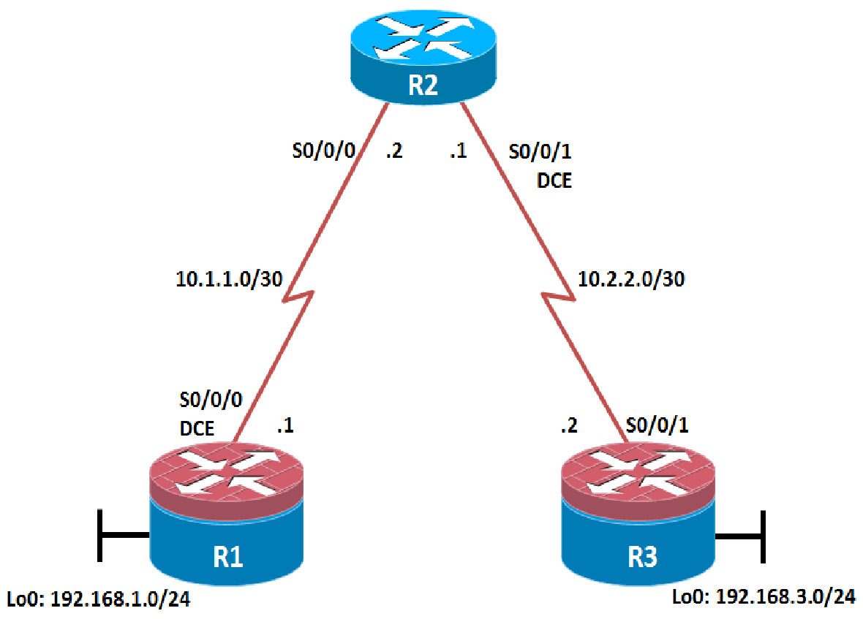

### Objectives

* Secure management access.
* Configure enhanced username password security.
* Enable AAA RADIUS authentication.
* Enable secure remote management.

### Background

The management plane of any infrastructure device should be protected as much as possible. Controlling access to routers and enabling reporting on routers are critical to network security and should be part of a comprehensive security policy.

In this lab, you build a multi-router network and secure the management plane of routers R1 and R3.

### Required Resources

* 3 routers (Cisco IOS Release 15.2 or comparable)
* Serial and Ethernet cables

### Step 1: Configure loopbacks and assign addresses.

Cable the network as shown in the topology diagram. Erase the startup configuration and reload each router to clear previous configurations. Using the addressing scheme in the diagram, apply the IP addresses to the interfaces on the R1, R2, and R3 routers.

You can copy and paste the following configurations into your routers to begin.

**Note**: Depending on the router model, interfaces might be numbered differently than those listed. You might need to alter the designations accordingly.

**R1**

R1(config)# hostname R1

R1(config)# interface Loopback 0

R1(config-if)# description R1 LAN

R1(config-if)# ip address 192.168.1.1 255.255.255.0

R1(config)# exit

R1(config)# interface Serial0/0/0

R1(config-if)# description R1 --> R2

R1(config-if)# ip address 10.1.1.1 255.255.255.252

R1(config-if)# clock rate 128000

R1(config-if)# no shutdown

R1(config)# exit

**R2**

R2(config)# exit

R2(config)# hostname R2

R2(config)# interface Serial0/0/0

R2(config-if)# description R2 --> R1

R2(config-if)# ip address 10.1.1.2 255.255.255.252

R2(config-if)# no shutdown

R2(config-if)# exit

R2(config)# interface Serial0/0/1

R2(config-if)# description R2 --> R3

R2(config-if)# ip address 10.2.2.1 255.255.255.252

R2(config-if)# clock rate 128000

R2(config-if)# no shutdown

R2(config-if)# exit

**R3**

R3(config)# hostname R3

R3(config)# interface Loopback0

R3(config-if)# description R3 LAN

R3(config-if)# ip address 192.168.3.1 255.255.255.0

R3(config-if)# exit

R3(config)# interface Serial0/0/1

R3(config-if)# description R3 --> R2

R3(config-if)# ip address 10.2.2.2 255.255.255.252

R3(config-if)# no shutdown

R3(config)# exit

Step 2: Configure static routes.

1. On R1, configure a default static route to ISP.

R1(config)# **ip route 0.0.0.0 0.0.0.0 10.1.1.2**

1. On R3, configure a default static route to ISP.

R3(config)# **ip route 0.0.0.0 0.0.0.0 10.2.2.1**

1. On R2, configure two static routes.

R2(config)# **ip route 192.168.1.0 255.255.255.0 10.1.1.1**

R2(config)# **ip route 192.168.3.0 255.255.255.0 10.2.2.2**

1. From the R1 router, run the following Tcl script to verify connectivity.

**foreach address {**

**192.168.1.1**

**10.1.1.1**

**10.1.1.2**

**10.2.2.1**

**10.2.2.2**

**192.168.3.1**

**} { ping $address }**

R1# **tclsh**

R1(tcl)#foreach address {

+>(tcl)#192.168.1.1

+>(tcl)#10.1.1.1

+>(tcl)#10.1.1.2

+>(tcl)#10.2.2.1

+>(tcl)#10.2.2.2

+>(tcl)#192.168.3.1

+>(tcl)#} { ping $address }

Type escape sequence to abort.

Sending 5, 100-byte ICMP Echos to 192.168.1.1, timeout is 2 seconds:

!!!!!

Success rate is 100 percent (5/5), round-trip min/avg/max = 1/1/1 ms

Type escape sequence to abort.

Sending 5, 100-byte ICMP Echos to 10.1.1.1, timeout is 2 seconds:

!!!!!

Success rate is 100 percent (5/5), round-trip min/avg/max = 1/2/4 ms

Type escape sequence to abort.

Sending 5, 100-byte ICMP Echos to 10.1.1.2, timeout is 2 seconds:

!!!!!

Success rate is 100 percent (5/5), round-trip min/avg/max = 1/1/4 ms

Type escape sequence to abort.

Sending 5, 100-byte ICMP Echos to 10.2.2.1, timeout is 2 seconds:

!!!!!

Success rate is 100 percent (5/5), round-trip min/avg/max = 1/1/4 ms

Type escape sequence to abort.

Sending 5, 100-byte ICMP Echos to 10.2.2.2, timeout is 2 seconds:

!!!!!

Success rate is 100 percent (5/5), round-trip min/avg/max = 12/14/16 ms

Type escape sequence to abort.

Sending 5, 100-byte ICMP Echos to 192.168.3.1, timeout is 2 seconds:

!!!!!

Success rate is 100 percent (5/5), round-trip min/avg/max = 12/15/16 ms

R1(tcl)#

Are the pings now successful?

Yes. If not, troubleshoot.

### Step 3: Secure management access.

1. On R1, use the **security passwords** command to set a minimum password length of 10 characters.

R1(config)# **security passwords min-length 10**

1. Configure the enable secret encrypted password on both routers.

R1(config)# **enable secret class12345**

How does configuring an enable secret password help protect a router from being compromised by an attack?

_______________________________________________________________________________________

_______________________________________________________________________________________

_______________________________________________________________________________________

The goal is to always prevent unauthorized users from accessing a device using Telnet, SSH, or via the console. If attackers are able to penetrate this first layer of defense, using an enable secret password prevents them from being able to alter the configuration of the device. Unless the enable secret password is known, a user cannot go into privileged EXEC mode where they can display the running config and enter various configuration commands to make changes to the router. This provides an additional layer of security.

Passwords in this task are set to a minimum of 10 characters but are relatively simple for the benefit of performing the lab. More complex passwords are recommended in a production network.

1. Configure a console password and enable login for routers. For additional security, the **exec-timeout** command causes the line to log out after 5 minutes of inactivity. The **logging synchronous** command prevents console messages from interrupting command entry.

**Note**: To avoid repetitive logins during this lab, the **exec-timeout** command can be set to 0 0, which prevents it from expiring. However, this is not considered a good security practice.

R1(config)# **line console 0**

R1(config-line)# **password ciscoconpass**

R1(config-line)# **exec-timeout 5 0**

R1(config-line)# **login**

R1(config-line)# **logging synchronous**

R1(config-line)# **exit**

R1(config)#

1. Configure the password on the vty lines for router R1.

R1(config)# **line vty 0 4**

R1(config-line)# **password ciscovtypass**

R1(config-line)# **exec-timeout 5 0**

R1(config-line)# **login**

R1(config-line)# **exit**

R1(config)#

1. The aux port is a legacy port used to manage a router remotely using a modem and is hardly ever used. Therefore, disable the aux port.

R1(config)# **line aux 0**

R1(config-line)# **no exec**

R1(config-line)# **end**

R1#

1. Enter privileged EXEC mode and issue the **show run** command. Can you read the enable secret password? Why or why not?

____________________________________________________________________________________

The enable secret password is encrypted automatically using the MD5 or SHA hash algorithm. . IOS 15.0(1)S and later default to SHA256 hashing algorithm. SHA256 which is considered to be a very strong hashing algorithm and is extremely difficult to reverse. Earlier IOS versions use the weaker MD5 hashing algorithm.

If the **enable secret** password command is lost or forgotten, it must be replaced using the Cisco router password recovery procedure. Refer to cisco.com for more information.

Can you read the console, aux, and vty passwords? Why or why not?

________________________________________________________________________________________________________________________________________________

Yes. They are all in clear text.

1. Use the **service password-encryption** command to encrypt the line console and vty passwords.

R1(config)# **service password-encryption**

R1(config)#

**Note:**  Password encryption is applied to all the passwords, including the **username** passwords, the authentication key passwords, the privileged command password, the console and the virtual terminal line access passwords, and the BGP neighbor passwords.

1. Issue the **show run** command.

Can you read the console, aux, and vty passwords? Why or why not?

____________________________________________________________________________________

____________________________________________________________________________________

No. The passwords are now encrypted.

**Note:**  Type 7 passwords are encrypted using a Vigenère cipher which can be easily reversed. Therefore this command primarily protects from shoulder surfing attacks.

1. Configure a warning to unauthorized users with a message-of-the-day (MOTD) banner using the **banner motd** command. When a user connects to one of the routers, the MOTD banner appears before the login prompt. In this example, the dollar sign ($) is used to start and end the message.

R1(config)# **banner motd $Unauthorized access strictly prohibited!$**

R1(config)# **exit**

1. Issue the **show run** command.

What does the $ convert to in the output?

____________________________________________________________________________________

____________________________________________________________________________________

The $ is converted to ^C when the running-config is displayed.

1. Exit privileged EXEC mode using the **disable** or **exit** command and press **Enter** to get started. Does the MOTD banner look like what you created with the **banner motd** command? If the MOTD banner is not as you wanted it, recreate it using the **banner motd** command.
2. Repeat the configuration portion of steps 3a through 3k on router R3.

### Step 4: Configure enhanced username password security.

To increase the encryption level of console and VTY lines, it is recommended to enable authentication using the local database. The local database consists of usernames and password combinations that are created locally on each device. The local and VTY lines are configured to refer to the local database when authenticating a user.

1. To create local database entry encrypted to level 4 (SHA256), use the **username** *name* **secret** *password* global configuration command. In global configuration mode, enter the following command:

R1(config)# **username JR-ADMIN secret class12345**

R1(config)# **username ADMIN secret class54321**

**Note:**  An older method for creating local database entries is to use the **username** *name* **password** *password* command.

1. Set the console line to use the locally defined login accounts.

R1(config)# **line console 0**

R1(config-line)# **login local**

R1(config-line)# **exit**

R1(config)#

1. Set the vty lines to use the locally defined login accounts.

R1(config)# **line vty 0 4**

R1(config-line)# **login local**

R1(config-line)# **end**

R1(config)#

1. Repeat the steps 4a to 4c on R3.
2. To verify the configuration, telnet to R3 from R1 and login using the ADMIN local database account.

R1# **telnet 10.2.2.2**

Trying 10.2.2.2 ... Open

Unauthorized access strictly prohibited!

User Access Verification

Username: **ADMIN**

Password:

R3>

### Step 5: Enabling AAA RADIUS Authentication with Local User for Backup.

Authentication, authorization, and accounting (AAA) is a standards-based framework that can be implemented to control who is permitted to access a network (authenticate), what they can do on that network (authorize), and audit what they did while accessing the network (accounting).

Users must authenticate against an authentication database which can be stored:

* **Locally**: Users are authenticated against the local device database which is created using the username secret command. Sometimes referred to self-contained AAA.
* **Centrally**: A client-server model where users are authenticated against AAA servers. This provides improved scalability, manageability and control. Communication between the device and AAA servers is secured using either the RADIUS or TACACS+ protocols.

In this step, we will configure AAA authentication to use a RADIUS server and the local database as a backup. Specifically, the authentication will be validated against one of two RADIUS servers. If the servers are not available, then authentication will be validated against the local database.

1. Always have local database accounts created before enabling AAA. Since we created two local database accounts in the previous step, then we can proceed and enable AAA on R1.

R1(config)# **aaa new-model**

**Note:**  Although the following configuration refers to two RADIUS servers, the actual RADIUS server implementation is beyond the scope. Therefore, the goal of this step is to provide an example of how to configure a router to access the servers.

1. Configure the specifics for the first RADIUS server located at 192.168.1.101. Use **RADIUS-1-pa55w0rd** as the server password.

R1(config)# **radius server RADIUS-1**

R1(config-radius-server)# **address ipv4 192.168.1.101**

R1(config-radius-server)# **key RADIUS-1-pa55w0rd**

R1(config-radius-server)# **exit**

1. Configure the specifics for the second RADIUS server located at 192.168.1.102. Use **RADIUS-2-pa55w0rd** as the server password.

R1(config)# **radius server RADIUS-2**

R1(config-radius-server)# **address ipv4 192.168.1.102**

R1(config-radius-server)# **key RADIUS-2-pa55w0rd**

R1(config-radius-server)# **exit**

1. Assign both RADIUS servers to a server group.

R1(config)# **aaa group server radius RADIUS-GROUP**

R1(config-sg-radius)# **server name RADIUS-1**

R1(config-sg-radius)# **server name RADIUS-2**

R1(config-sg-radius)# **exit**

1. Enable the default AAA authentication login to attempt to validate against the server group. If they are not available, then authentication should be validated against the local database..

R1(config)# **aaa authentication login default group RADIUS-GROUP local**

**Note:**  Once this command is configured, all line access methods default to the default authentication method. The **local** option enables AAA to refer to the local database. Only the password is case sensitive.

1. Enable the default AAA authentication Telnet login to attempt to validate against the server group. If they are not available, then authentication should be validated against a case sensitive local database.

R1(config)# **aaa authentication login TELNET-LOGIN group RADIUS-GROUP local-case**

**Note:**  Unlike the **local** option that makes the password is case sensitive, local-case makes the username and password case sensitive.

1. Alter the VTY lines to use the TELNET-LOGIN AAA authentiaito0n method.

R1(config)# **line vty 0 4**

R1(config-line)# **login authentication TELNET-LOGIN**

R1(config-line)# **exit**

R1(config)#

1. Repeat the steps 5a to 5g on R3.
2. To verify the configuration, telnet to R3 from R1 and login using the ADMIN local database account.

R1# **telnet 10.2.2.2**

Trying 10.2.2.2 ... Open

Unauthorized access strictly prohibited!

User Access Verification

Username: **admin**

Password:

% Authentication failed

Username: **ADMIN**

Password:

R3>

**Note:** The first login attempt did not use the correct username (i.e., ADMIN) which is why it failed.

**Note:** The actual login time is longer since the RADIUS servers are not available.

### Step 6: Enabling secure remote management using SSH.

Traditionally, remote access on routers was configured using Telnet on TCP port 23. However, Telnet was developed in the days when security was not an issue; therefore, all Telnet traffic is forwarded in plaintext.

Secure Shell (SSH) is a network protocol that establishes a secure terminal emulation connection to a router or other networking device. SSH encrypts all information that passes over the network link and provides authentication of the remote computer. SSH is rapidly replacing Telnet as the remote login tool of choice for network professionals.

**Note**: For a router to support SSH, it must be configured with local authentication, (AAA services, or username) or password authentication. In this task, you configure an SSH username and local authentication.

In this step, you will enable R1 and R3 to support SSH instead of Telnet.

1. SSH requires that a device name and a domain name be configured. Since the router already has a name assigned, configure the domain name.

R1(config)# **ip domain-name ccnasecurity.com**

1. The router uses the RSA key pair for authentication and encryption of transmitted SSH data. Although optional it may be wise to erase any existing key pairs on the router.

R1(config)# **crypto key zeroize rsa**

**Note**: If no keys exist, you might receive this message: % No Signature RSA Keys found in configuration.

1. Generate the RSA encryption key pair for the router. Configure the RSA keys with **1024** for the number of modulus bits. The default is 512, and the range is from 360 to 2048.

R1(config)# **crypto key generate rsa general-keys modulus 1024**

The name for the keys will be: R1.ccnasecurity.com

% The key modulus size is 1024 bits

% Generating 1024 bit RSA keys, keys will be non-exportable...[OK]

R1(config)#

Jan 10 13:44:44.711: %SSH-5-ENABLED: SSH 1.99 has been enabled

1. Cisco routers support two versions of SSH:

* **SSH version 1 (SSHv1)**: Original version but has known vulnerabilities.
* **SSH version 2 (SSHv2)**: Provides better security using the Diffie-Hellman key exchange and the strong integrity-checking message authentication code (MAC).

The default setting for SSH is SSH version 1.99. This is also known as compatibility mode and is merely an indication that the server supports both SSH version 2 and SSH version 1. However, best practices are to enable version 2 only.

Configure SSH version 2 on R1.

R1(config)# **ip ssh version 2**

1. Configure the vty lines to use only SSH connections.

R1(config)# **line vty 0 4**

R1(config-line)# **transport input ssh**

R1(config-line)# **end**

**Note**: SSH requires that the **login local** command be configured. However, in the previous step we enabled AAA authentication using the TELNET-LOGIN authentication method, therefore **login local** is not necessary.

**Note**: If you add the keyword **telnet** to the **transport input** command, users can log in using Telnet as well as SSH. However, the router will be less secure. If only SSH is specified, the connecting host must have an SSH client installed.

1. Verify the SSH configuration using the **show ip ssh** command.

R1# **show ip ssh**

SSH Enabled - version 2.0

Authentication timeout: 120 secs; Authentication retries: 3

Minimum expected Diffie Hellman key size : 1024 bits

IOS Keys in SECSH format(ssh-rsa, base64 encoded):

ssh-rsa AAAAB3NzaC1yc2EAAAADAQABAAAAgQC3Lehh7ReYlgyDzls6wq+mFzxqzoaZFr9XGx+Q/yio

dFYw00hQo80tZy1W1Ff3Pz6q7Qi0y00urwddHZ0kBZceZK9EzJ6wZ+9a87KKDETCWrGSLi6c8lE/y4K+

Z/oVrMMZk7bpTM1MFdP41YgkTf35utYv+TcqbsYo++KJiYk+xw==

R1#

1. Repeat the steps 6a to 6f on R3.
2. Although a user can SSH from a host using the SSH option of TeraTerm of PuTTY, a router can also SSH to another SSH enabled device. SSH to R3 from R1.

R1# **ssh -l ADMIN 10.2.2.2**

Password:

Unauthorized access strictly prohibited!

R3>

R3> **en**

Password:

R3

### Practical No.5

### Configure and Verify Path Control Using PBR

### Topology

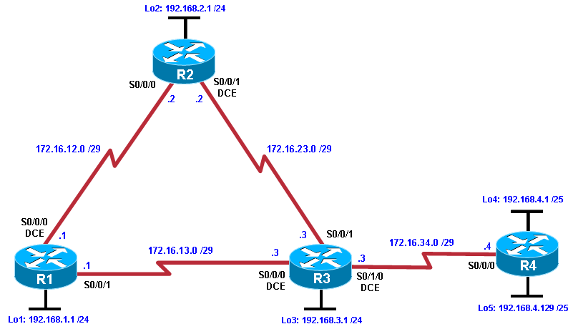

### Objectives

* Configure and verify policy-based routing.
* Select the required tools and commands to configure policy-based routing operations.
* Verify the configuration and operation by using the proper show and debug commands.

### Background

You want to experiment with policy-based routing (PBR) to see how it is implemented and to study how it could be of value to your organization. To this end, you have interconnected and configured a test network with four routers. All routers are exchanging routing information using EIGRP.

**Note:** This lab uses Cisco 1941 routers with Cisco IOS Release 15.2 with IP Base. Depending on the router or switch model and Cisco IOS Software version, the commands available and output produced might vary from what is shown in this lab.

### Required Resources

* 4 routers (Cisco IOS Release 15.2 or comparable)
* Serial and Ethernet cables

### Step 1: Configure loopbacks and assign addresses.

1. Cable the network as shown in the topology diagram. Erase the startup configuration, and reload each router to clear previous configurations.
2. Using the addressing scheme in the diagram, create the loopback interfaces and apply IP addresses to these and the serial interfaces on R1, R2, R3, and R4. On the serial interfaces connecting R1 to R3 and R3 to R4, specify the bandwidth as 64 Kb/s and set a clock rate on the DCE using the **clock rate 64000** command. On the serial interfaces connecting R1 to R2 and R2 to R3, specify the bandwidth as 128 Kb/s and set a clock rate on the DCE using the **clock rate 128000** command.

You can copy and paste the following configurations into your routers to begin.

**Note**: Depending on the router model, interfaces might be numbered differently than those listed. You might need to alter them accordingly.

**Router R1**

R1(config)#hostname R1

R1(config)#interface Lo1

 R1(config-if)#description R1 LAN

 R1(config-if)#ip address 192.168.1.1 255.255.255.0

R1(config-if)#exit

R1(config)#interface Serial0/0/0

R1(config-if)#description R1 --> R2

R1(config-if)#ip address 172.16.12.1 255.255.255.248

R1(config-if)#clock rate 128000

R1(config-if)#bandwidth 128

R1(config-if)#no shutdown

R1(config-if)#exit

R1(config)#interface Serial0/0/1

R1(config-if)#description R1 --> R3

R1(config-if)#ip address 172.16.13.1 255.255.255.248

R1(config-if)#bandwidth 64

R1(config-if)#no shutdown

R1(config-if)#exit

**Router R2**

R2(config)#hostname R2

R2(config-if)#interface Lo2

R2(config-if)# description R2 LAN

R2(config-if)# ip address 192.168.2.1 255.255.255.0

R2(config-if)#interface Serial0/0/0

R2(config-if)# description R2 --> R1

R2(config-if)# ip address 172.16.12.2 255.255.255.248

R2(config-if)#bandwidth 128

R2(config-if)#no shutdown

R2(config-if)#interface Serial0/0/1

R2(config-if)# description R2 --> R3

R2(config-if)#ip address 172.16.23.2 255.255.255.248

R2(config-if)# clock rate 128000

R2(config-if)# bandwidth 128

R2(config-if)#no shutdown

R2(config-if)#end

**Router R3**

R3(config)#hostname R3

R3(config-if)#interface Lo3

R3(config-if)#description R3 LAN

R3(config-if)#ip address 192.168.3.1 255.255.255.0

R3(config-if)#interface Serial0/0/0

R3(config-if)#description R3 --> R1

R3(config-if)#ip address 172.16.13.3 255.255.255.248

R3(config-if)#clock rate 64000

R3(config-if)#bandwidth 64

R3(config-if)#no shutdown

R3(config-if)#interface Serial0/0/1

R3(config-if)#description R3 --> R2

R3(config-if)#ip address 172.16.23.3 255.255.255.248

R3(config-if)#bandwidth 128

R3(config-if)#no shutdown

R3(config-if)#interface Serial0/1/0

R3(config-if)#description R3 --> R4

R3(config-if)#ip address 172.16.34.3 255.255.255.248

R3(config-if)#clock rate 64000

R3(config-if)#bandwidth 64

R3(config-if)#no shutdown

R3(config-if)#end

**Router R4**

R4(config)#hostname R4

R4(config-if)#interface Lo4

R4(config-if)#description R4 LAN A

R4(config-if)#ip address 192.168.4.1 255.255.255.128

R4(config-if)#interface Lo5

R4(config-if)#description R4 LAN B

R4(config-if)#ip address 192.168.4.129 255.255.255.128

R4(config-if)#interface Serial0/0/0

R4(config-if)#description R4 --> R3

R4(config-if)#ip address 172.16.34.4 255.255.255.248

R4(config-if)#bandwidth 64

R4(config-if)#no shutdown

R4(config-if)#end

1. Verify the configuration with the **show ip interface brief**, **show protocols,** and **show interfaces description** commands. The output from router R3 is shown here as an example.

R3# **show ip interface brief | include up**

Serial0/0/0 172.16.13.3 YES manual up up

Serial0/0/1 172.16.23.3 YES manual up up

Serial0/1/0 172.16.34.3 YES manual up up

Loopback3 192.168.3.1 YES manual up up

R3# **show protocols**

Global values:

Internet Protocol routing is enabled

Embedded-Service-Engine0/0 is administratively down, line protocol is down

GigabitEthernet0/0 is administratively down, line protocol is down

GigabitEthernet0/1 is administratively down, line protocol is down

Serial0/0/0 is up, line protocol is up

Internet address is 172.16.13.3/29

Serial0/0/1 is up, line protocol is up

Internet address is 172.16.23.3/29

Serial0/1/0 is up, line protocol is up

Internet address is 172.16.34.3/29

Serial0/1/1 is administratively down, line protocol is down

Loopback3 is up, line protocol is up

Internet address is 192.168.3.1/24

R3# **show interfaces description | include up**

Se0/0/0 up up R3 --> R1

Se0/0/1 up up R3 --> R2

Se0/1/0 up up R3 --> R4

Lo3 up up R3 LAN

**Step 3: Configure basic EIGRP.**

1. Implement EIGRP AS 1 over the serial and loopback interfaces as you have configured it for the other EIGRP labs.
2. Advertise networks 172.16.12.0/29, 172.16.13.0/29, 172.16.23.0/29, 172.16.34.0/29, 192.168.1.0/24, 192.168.2.0/24, 192.168.3.0/24, and 192.168.4.0/24 from their respective routers.

You can copy and paste the following configurations into your routers.

**Router R1**

R1(config)#router eigrp 1

R1(config-router)#network 192.168.1.0

 R1(config-router)#network 172.16.12.0 0.0.0.7

 R1(config-router)#network 172.16.13.0 0.0.0.7

R1(config-router)#no auto-summary

**Router R2**

R2(config)#router eigrp 1

R2(config-router)#network 192.168.2.0

R2(config-router)#network 172.16.12.0 0.0.0.7

R2(config-router)#network 172.16.23.0 0.0.0.7

R2(config-router)#no auto-summary

**Router R3**

R3(config)#router eigrp 1

R3(config-router)#network 192.168.3.0

R3(config-router)#network 172.16.13.0 0.0.0.7

R3(config-router)#network 172.16.23.0 0.0.0.7

R3(config-router)#network 172.16.34.0 0.0.0.7

R3(config-router)#no auto-summary

**Router R4**

R4(config)#router eigrp 1

R4(config-router)#network 192.168.4.0

R4(config-router)#network 172.16.34.0 0.0.0.7

R4(config-router)#no auto-summary

You should see EIGRP neighbor relationship messages being generated.

**Step 4: Verify EIGRP connectivity.**

1. Verify the configuration by using the **show ip eigrp neighbors** command to check which routers have EIGRP adjacencies.

R1# **show ip eigrp neighbors**

EIGRP-IPv4 Neighbors for AS(1)

H Address Interface Hold Uptime SRTT RTO Q Seq

(sec) (ms) Cnt Num

1 172.16.13.3 Se0/0/1 10 00:01:55 27 2340 0 9

0 172.16.12.2 Se0/0/0 13 00:02:07 8 1170 0 11

R2# **show ip eigrp neighbors**

EIGRP-IPv4 Neighbors for AS(1)

H Address Interface Hold Uptime SRTT RTO Q Seq

(sec) (ms) Cnt Num

1 172.16.23.3 Se0/0/1 12 00:02:15 12 1170 0 10

0 172.16.12.1 Se0/0/0 11 00:02:27 9 1170 0 13

R3# **show ip eigrp neighbors**

EIGRP-IPv4 Neighbors for AS(1)

H Address Interface Hold Uptime SRTT RTO Q Seq

(sec) (ms) Cnt Num

2 172.16.34.4 Se0/1/0 12 00:02:14 44 2340 0 3

1 172.16.23.2 Se0/0/1 11 00:02:23 10 1170 0 10

0 172.16.13.1 Se0/0/0 10 00:02:23 1031 5000 0 12

R4# **show ip eigrp neighbors**

EIGRP-IPv4 Neighbors for AS(1)

H Address Interface Hold Uptime SRTT RTO Q Seq

(sec) (ms) Cnt Num

0 172.16.34.3 Se0/0/0 10 00:02:22 37 2340 0 11

Did you receive the output you expected?

1. Run the following Tcl script on all routers to verify full connectivity.

R1# **tclsh**

**foreach address {**

**172.16.12.1**

**172.16.12.2**

**172.16.13.1**

**172.16.13.3**

**172.16.23.2**

**172.16.23.3**

**172.16.34.3**

**172.16.34.4**

**192.168.1.1**

**192.168.2.1**

**192.168.3.1**

**192.168.4.1**

**192.168.4.129**

**} { ping $address }**

You should get ICMP echo replies for every address pinged. Make sure to run the Tcl script on each router.

**Step 5: Verify the current path.**

Before you configure PBR, verify the routing table on R1.

1. On R1, use the **show ip route** command. Notice the next-hop IP address for all networks discovered by EIGRP.

R1# **show ip route | begin Gateway**

Gateway of last resort is not set

172.16.0.0/16 is variably subnetted, 6 subnets, 2 masks

C 172.16.12.0/29 is directly connected, Serial0/0/0

L 172.16.12.1/32 is directly connected, Serial0/0/0

C 172.16.13.0/29 is directly connected, Serial0/0/1

L 172.16.13.1/32 is directly connected, Serial0/0/1

D 172.16.23.0/29 [90/21024000] via 172.16.12.2, 00:07:22, Serial0/0/0

D 172.16.34.0/29 [90/41024000] via 172.16.13.3, 00:07:22, Serial0/0/1

192.168.1.0/24 is variably subnetted, 2 subnets, 2 masks

C 192.168.1.0/24 is directly connected, Loopback1

L 192.168.1.1/32 is directly connected, Loopback1

D 192.168.2.0/24 [90/20640000] via 172.16.12.2, 00:07:22, Serial0/0/0

D 192.168.3.0/24 [90/21152000] via 172.16.12.2, 00:07:22, Serial0/0/0

192.168.4.0/25 is subnetted, 2 subnets

D 192.168.4.0 [90/41152000] via 172.16.13.3, 00:07:14, Serial0/0/1

D 192.168.4.128 [90/41152000] via 172.16.13.3, 00:07:14, Serial0/0/1

1. On R4, use the **traceroute** command to the R1 LAN address and source the ICMP packet from R4 LAN A and LAN B.

**Note:** You can specify the source as the interface address (for example 192.168.4.1) or the interface designator (for example, Fa0/0).

R4# **traceroute 192.168.1.1 source 192.168.4.1**

Type escape sequence to abort.

Tracing the route to 192.168.1.1

VRF info: (vrf in name/id, vrf out name/id)

1 172.16.34.3 12 msec 12 msec 16 msec

2 172.16.23.2 20 msec 20 msec 20 msec

3 172.16.12.1 24 msec * 24 msec

R4# **traceroute 192.168.1.1 source 192.168.4.129**

Type escape sequence to abort.

Tracing the route to 192.168.1.1

VRF info: (vrf in name/id, vrf out name/id)

1 172.16.34.3 12 msec 16 msec 12 msec

2 172.16.23.2 28 msec 20 msec 16 msec

3 172.16.12.1 24 msec * 24 msec

Notice that the path taken for the packets sourced from the R4 LANs are going through R3 --> R2 --> R1.

Why are the R4 interfaces not using the R3 --> R1 path?

1. On R3, use the **show ip route** command and note that the preferred route from R3 to R1 LAN 192.168.1.0/24 is via R2 using the R3 exit interface S0/0/1.

R3# **show ip route | begin Gateway**

Gateway of last resort is not set

172.16.0.0/16 is variably subnetted, 7 subnets, 2 masks

D 172.16.12.0/29 [90/21024000] via 172.16.23.2, 00:10:54, Serial0/0/1

C 172.16.13.0/29 is directly connected, Serial0/0/0

L 172.16.13.3/32 is directly connected, Serial0/0/0

C 172.16.23.0/29 is directly connected, Serial0/0/1

L 172.16.23.3/32 is directly connected, Serial0/0/1

C 172.16.34.0/29 is directly connected, Serial0/1/0

L 172.16.34.3/32 is directly connected, Serial0/1/0

D 192.168.1.0/24 [90/21152000] via 172.16.23.2, 00:10:54, Serial0/0/1

D 192.168.2.0/24 [90/20640000] via 172.16.23.2, 00:10:54, Serial0/0/1

192.168.3.0/24 is variably subnetted, 2 subnets, 2 masks

C 192.168.3.0/24 is directly connected, Loopback3

L 192.168.3.1/32 is directly connected, Loopback3

192.168.4.0/25 is subnetted, 2 subnets

D 192.168.4.0 [90/40640000] via 172.16.34.4, 00:10:47, Serial0/1/0

D 192.168.4.128 [90/40640000] via 172.16.34.4, 00:10:47, Serial0/1/0

1. On R3, use the **show interfaces serial 0/0/0** and **show interfaces s0/0/1** commands.

R3# **show interfaces serial0/0/0**

Serial0/0/0 is up, line protocol is up

Hardware is WIC MBRD Serial

Description: R3 --> R1

Internet address is 172.16.13.3/29

MTU 1500 bytes, BW 64 Kbit/sec, DLY 20000 usec,

reliability 255/255, txload 1/255, rxload 1/255

Encapsulation HDLC, loopback not set

Keepalive set (10 sec)

Last input 00:00:01, output 00:00:00, output hang never

Last clearing of "show interface" counters never

Input queue: 0/75/0/0 (size/max/drops/flushes); Total output drops: 0

Queueing strategy: fifo

Output queue: 0/40 (size/max)

5 minute input rate 0 bits/sec, 0 packets/sec

5 minute output rate 0 bits/sec, 0 packets/sec

399 packets input, 29561 bytes, 0 no buffer

Received 186 broadcasts (0 IP multicasts)

0 runts, 0 giants, 0 throttles

0 input errors, 0 CRC, 0 frame, 0 overrun, 0 ignored, 0 abort

393 packets output, 29567 bytes, 0 underruns

0 output errors, 0 collisions, 3 interface resets

0 unknown protocol drops

0 output buffer failures, 0 output buffers swapped out

0 carrier transitions

DCD=up DSR=up DTR=up RTS=up CTS=up

R3# **show interfaces serial0/0/0 | include BW**

MTU 1500 bytes, BW 64 Kbit/sec, DLY 20000 usec,

R3# **show interfaces serial0/0/1 | include BW**

MTU 1500 bytes, BW 128 Kbit/sec, DLY 20000 usec,

Notice that the bandwidth of the serial link between R3 and R1 (S0/0/0) is set to 64 Kb/s, while the bandwidth of the serial link between R3 and R2 (S0/0/1) is set to 128 Kb/s.

1. Confirm that R3 has a valid route to reach R1 from its serial 0/0/0 interface using the **show ip eigrp topology 192.168.1.0** command.

R3# **show ip eigrp topology 192.168.1.0**

EIGRP-IPv4 Topology Entry for AS(1)/ID(192.168.3.1) for 192.168.1.0/24

State is Passive, Query origin flag is 1, 1 Successor(s), FD is 21152000

Descriptor Blocks:

172.16.23.2 (Serial0/0/1), from 172.16.23.2, Send flag is 0x0

Composite metric is (21152000/20640000), route is Internal

Vector metric:

Minimum bandwidth is 128 Kbit

Total delay is 45000 microseconds

Reliability is 255/255

Load is 1/255

Minimum MTU is 1500

Hop count is 2

Originating router is 192.168.1.1

172.16.13.1 (Serial0/0/0), from 172.16.13.1, Send flag is 0x0

Composite metric is (40640000/128256), route is Internal

Vector metric:

Minimum bandwidth is 64 Kbit

Total delay is 25000 microseconds

Reliability is 255/255

Load is 1/255

Minimum MTU is 1500

Hop count is 1

Originating router is 192.168.1.1

As indicated, R4 has two routes to reach 192.168.1.0. However, the metric for the route to R1 (172.16.13.1) is much higher (40640000) than the metric of the route to R2 (21152000), making the route through R2 the successor route.

**Step 6: Configure PBR to provide path control.**

Now you will deploy source-based IP routing by using PBR. You will change a default IP routing decision based on the EIGRP-acquired routing information for selected IP source-to-destination flows and apply a different next-hop router.

Recall that routers normally forward packets to destination addresses based on information in their routing table. By using PBR, you can implement policies that selectively cause packets to take different paths based on source address, protocol type, or application type. Therefore, PBR overrides the router’s normal routing behavior.

Configuring PBR involves configuring a route map with **match** and **set** commands and then applying the route map to the interface.

The steps required to implement path control include the following:

* Choose the path control tool to use. Path control tools manipulate or bypass the IP routing table. For PBR, **route-map** commands are used.
* Implement the traffic-matching configuration, specifying which traffic will be manipulated. The **match** commands are used within route maps.
* Define the action for the matched traffic using **set** commands within route maps.
* Apply the route map to incoming traffic.

As a test, you will configure the following policy on router R3:

* All traffic sourced from R4 LAN A must take the R3 --> R2 --> R1 path.
* All traffic sourced from R4 LAN B must take the R3 --> R1 path.

1. On router R3, create a standard access list called **PBR-ACL** to identify the R4 LAN B network.

R3(config)# **ip access-list standard PBR-ACL**

R3(config-std-nacl)# **remark ACL matches R4 LAN B traffic**

R3(config-std-nacl)# **permit 192.168.4.128 0.0.0.127**

R3(config-std-nacl)# **exit**

R3(config)#

1. Create a route map called **R3-to-R1** that matches PBR-ACL and sets the next-hop interface to the R1 serial 0/0/1 interface.

R3(config)# **route-map R3-to-R1 permit**

R3(config-route-map)# **description RM to forward LAN B traffic to R1**

R3(config-route-map)# **match ip address PBR-ACL**

R3(config-route-map)# **set ip next-hop 172.16.13.1**

R3(config-route-map)# **exit**

R3(config)#

1. Apply the R3-to-R1 route map to the serial interface on R3 that receives the traffic from R4. Use the **ip policy route-map** command on interface S0/1/0.

R3(config)# **interface s0/1/0**

R3(config-if)# **ip policy route-map R3-to-R1**

R3(config-if)# **end**

1. On R3, display the policy and matches using the **show route-map** command.

R3# **show route-map**

route-map R3-to-R1, permit, sequence 10

Match clauses:

ip address (access-lists): PBR-ACL

Set clauses:

ip next-hop 172.16.13.1

Policy routing matches: 0 packets, 0 bytes

**Note:** There are currently no matches because no packets matching the ACL have passed through R3 S0/1/0.

**Step 7: Test the policy.**

Now you are ready to test the policy configured on R3. Enable the **debug ip policy** command on R3 so that you can observe the policy decision-making in action. To help filter the traffic, first create a standard ACL that identifies all traffic from the R4 LANs.

1. On R3, create a standard ACL which identifies all of the R4 LANs.

R3# **conf t**

R3(config)# **access-list 1 permit 192.168.4.0 0.0.0.255**

R3(config)# **exit**

1. Enable PBR debugging only for traffic that matches the R4 LANs.

R3# **debug ip policy ?**

<1-199> Access list

dynamic dynamic PBR

<cr>

R3# **debug ip policy 1**

Policy routing debugging is on for access list 1

1. Test the policy from R4 with the **traceroute** command, using R4 LAN A as the source network.

R4# **traceroute 192.168.1.1 source 192.168.4.1**

Type escape sequence to abort.

Tracing the route to 192.168.1.1

1 172.16.34.3 0 msec 0 msec 4 msec

2 172.16.23.2 0 msec 0 msec 4 msec

3 172.16.12.1 4 msec 0 msec *

Notice the path taken for the packet sourced from R4 LAN A is still going through R3 --> R2 --> R1.

As the traceroutewas being executed, router R3 should be generating the following debug output.

R3#

Jan 10 10:49:48.411: IP: s=192.168.4.1 (Serial0/1/0), d=192.168.1.1, len 28, policy rejected -- normal forwarding

Jan 10 10:49:48.427: IP: s=192.168.4.1 (Serial0/1/0), d=192.168.1.1, len 28, policy rejected -- normal forwarding

Jan 10 10:49:48.439: IP: s=192.168.4.1 (Serial0/1/0), d=192.168.1.1, len 28, policy rejected -- normal forwarding

Jan 10 10:49:48.451: IP: s=192.168.4.1 (Serial0/1/0), d=192.168.1.1, len 28, FIB policy rejected(no match) - normal forwarding

Jan 10 10:49:48.471: IP: s=192.168.4.1 (Serial0/1/0), d=192.168.1.1, len 28, FIB policy rejected(no match) - normal forwarding

Jan 10 10:49:48.491: IP: s=192.168.4.1 (Serial0/1/0), d=192.168.1.1, len 28, FIB policy rejected(no match) - normal forwarding

Jan 10 10:49:48.511: IP: s=192.168.4.1 (Serial0/1/0), d=192.168.1.1, len 28, FIB policy rejected(no match) - normal forwarding

Jan 10 10:49:48.539: IP: s=192.168.4.1 (Serial0/1/0), d=192.168.1.1, len 28, FIB policy rejected(no match) - normal forwarding

Jan 10 10:49:51.539: IP: s=192.168.4.1 (Serial0/1/0), d=192.168.1.1, len 28, FIB policy rejected(no match) - normal forwarding

R3#

Why is the traceroute traffic not using the R3 --> R1 path as specified in the R3-to-R1 policy?

1. Test the policy from R4 with the **traceroute** command, using R4 LAN B as the source network.

R4# **traceroute 192.168.1.1 source 192.168.4.129**

Type escape sequence to abort.

Tracing the route to 192.168.1.1

1 172.16.34.3 12 msec 12 msec 16 msec

2 172.16.13.1 28 msec 28 msec *

Now the path taken for the packet sourced from R4 LAN B is R3 --> R1, as expected.

The debug output on R3 also confirms that the traffic meets the criteria of the R3-to-R1 policy.

Jan 10 10:50:04.283: IP: s=192.168.4.129 (Serial0/1/0), d=192.168.1.1, len 28, policy match

Jan 10 10:50:04.283: IP: route map R3-to-R1, item 10, permit

Jan 10 10:50:04.283: IP: s=192.168.4.129 (Serial0/1/0), d=192.168.1.1 (Serial0/0/0), len 28, policy routed

Jan 10 10:50:04.283: IP: Serial0/1/0 to Serial0/0/0 172.16.13.1

Jan 10 10:50:04.295: IP: s=192.168.4.129 (Serial0/1/0), d=192.168.1.1, len 28, policy match

Jan 10 10:50:04.295: IP: route map R3-to-R1, item 10, permit

Jan 10 10:50:04.295: IP: s=192.168.4.129 (Serial0/1/0), d=192.168.1.1 (Serial0/0/0), len 28, policy routed

Jan 10 10:50:04.295: IP: Serial0/1/0 to Serial0/0/0 172.16.13.1

Jan 10 10:50:04.311: IP: s=192.168.4.129 (Serial0/1/0), d=192.168.1.1, len 28, policy match

Jan 10 10:50:04.311: IP: route map R3-to-R1, item 10, permit

Jan 10 10:50:04.311: IP: s=192.168.4.129 (Serial0/1/0), d=192.168.1.1 (Serial0/0/0), len 28, policy routed

Jan 10 10:50:04.311: IP: Serial0/1/0 to Serial0/0/0 172.16.13.1

Jan 10 10:50:04.323: IP: s=192.168.4.129 (Serial0/1/0), d=192.168.1.1, len 28, FIB policy match

Jan 10 10:50:04.323: IP: s=192.168.4.129 (Serial0/1/0), d=192.168.1.1, len 28, PBR Counted

Jan 10 10:50:04.323: IP: s=192.168.4.129 (Serial0/1/0), d=192.168.1.1, g=172.16.13.1, len 28, FIB policy routed

Jan 10 10:50:04.351: IP: s=192.168.4.129 (Serial0/1/0), d=192.168.1.1, len 28, FIB policy match

Jan 10 10:50:04.351: IP: s=192.168.4.129 (Serial0/1/0), d=192.168.1.1, len 28, PBR Counted

Jan 10 10:50:04.351: IP: s=192.168.4.129 (Serial0/1/0), d=192.168.1.1, g=172.16.13.1, len 28, FIB policy routed

Jan 10 10:50:07.347: IP: s=192.168.4.129 (Serial0/1/0), d=192.168.1.1, len 28, FIB policy match

Jan 10 10:50:07.347: IP: s=192.168.4.129 (Serial0/1/0), d=192.168.1.1, len 28, PBR Counted

Jan 10 10:50:07.347: IP: s=192.168.4.129 (Serial0/1/0), d=192.168.1.1, g=172.16.13.1, len 28, FIB policy routed

1. On R3, display the policy and matches using the **show route-map** command.

R3# **show route-map**

route-map R3-to-R1, permit, sequence 10

Match clauses:

ip address (access-lists): PBR-ACL

Set clauses:

ip next-hop 172.16.13.1

Nexthop tracking current: 0.0.0.0

172.16.13.1, fib_nh:0,oce:0,status:0

Policy routing matches: 12 packets, 384 bytes

R3#

**Note:** There are now matches to the policy because packets matching the ACL have passed through R3 S0/1/0.

**PRACTICAL NO. 7**

**Basic Inter-VLAN Routing**

**Topology Diagram**

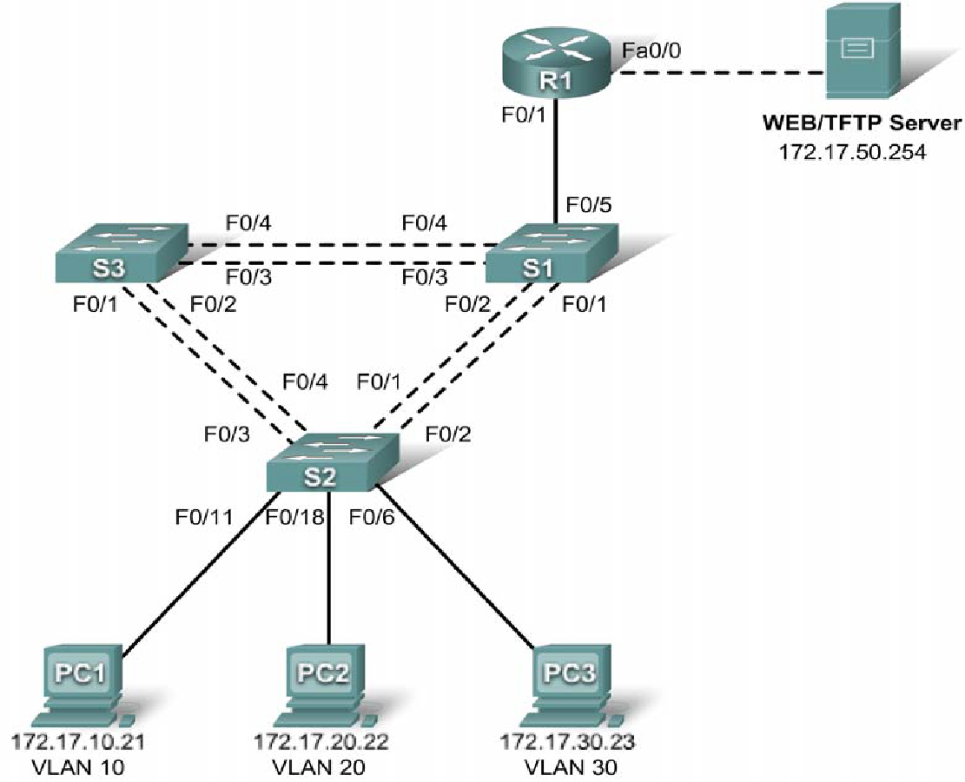

**Addressing Table –**

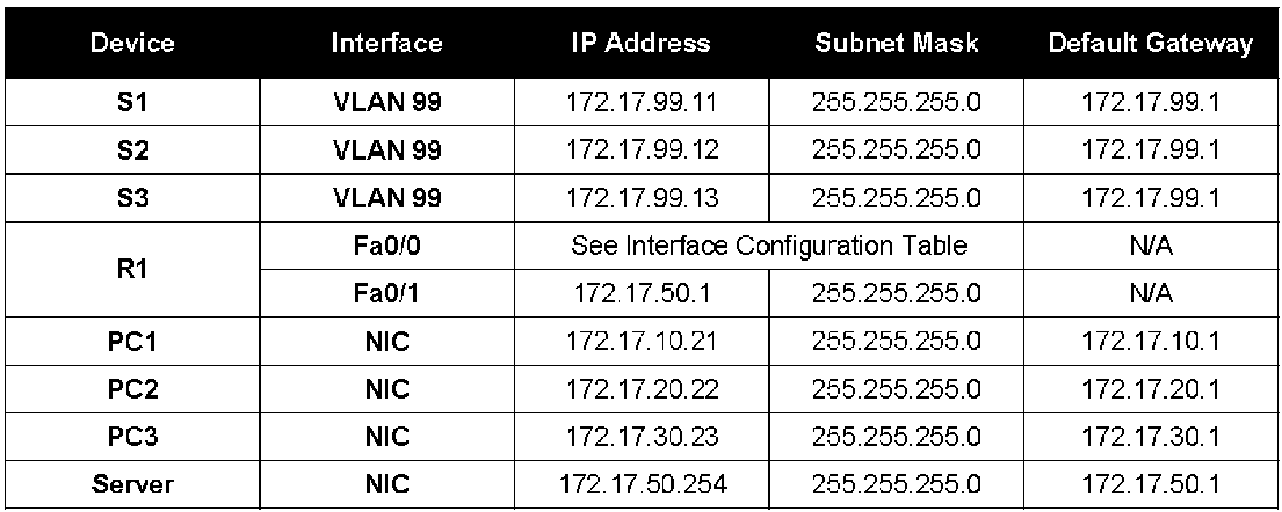

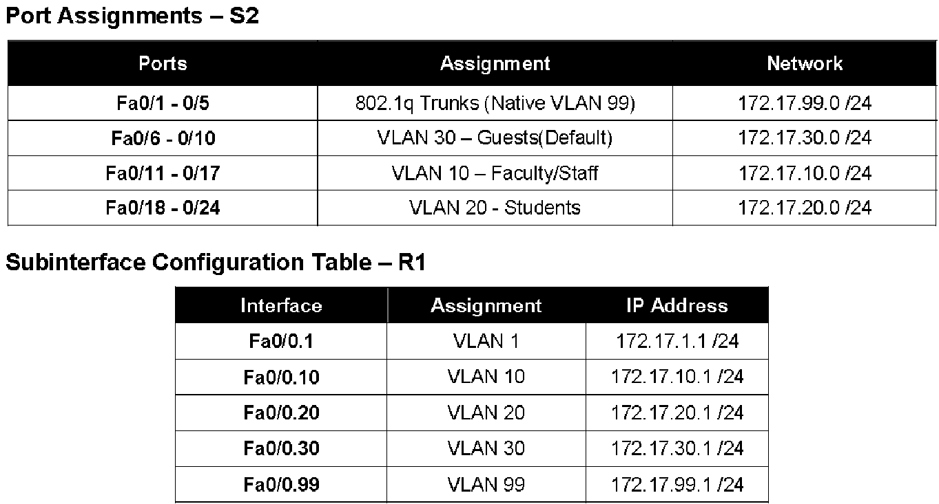

**Learning Objectives**

• Perform basic switch configurations

• Configure the Ethernet interfaces on the host PCs

• Configure VTP on the switches

• Configure the router and the remote server LAN

**Introduction**

In this activity, you will perform basic switch configurations, configure addressing on PCs, configure VTP and inter-VLAN routing.

**Task 1: Perform Basic Switch Configurations**

Configure the S1, S2, and S3 switches according to the addressing table and the following guidelines:

• Configure the switch hostname.

• Disable DNS lookup.

• Configure the default gateway.

• Configure an EXEC mode password of **class**.

• Configure a password of **cisco** for console connections.

• Configure a password of **cisco** for vty connections.

• Configure the default gateway on each switch.

Switch>**enable**

Switch#**config term**

Switch(config)#**hostname S1**

S1(config)#**enable secret class**

S1(config)#**no ip domain-lookup**

S1(config)#**ip default-gateway 172.17.99.1**

S1(config)#**line console 0**

S1(config-line)#**password cisco**

S1(config-line)#**login**

S1(config-line)#**line vty 0 15**

S1(config-line)#**password cisco**

S1(config-line)#**login**

S1(config-line)#**end**

%SYS-5-CONFIG_I: Configured from console by console

S1#**copy running-config startup-config**

Destination filename [startup-config]? [enter]

Building configuration...

**Task 2: Configure the Ethernet Interfaces on the Host PCs**

Configure the Ethernet interfaces of PC1, PC2 and PC3 with the IP addresses from the addressing table.

**Task 3: Configure VTP on the Switches**

**Step 1. Enable the user ports on S2 in access mode.**

S2(config)#**interface fa0/6**

S2(config-if)#**switchport mode access**

S2(config-if)#**no shutdown**

S2(config-if)#**interface fa0/11**

S2(config-if)#**switchport mode access**

S2(config-if)#**no shutdown**

S2(config-if)#**interface fa0/18**

S2(config-if)#**switchport mode access**

S2(config-if)#**no shutdown**

**Step 2. Configure VTP.**

Configure VTP on the three switches using the following table. Remember that VTP domain names and passwords are case-sensitive.

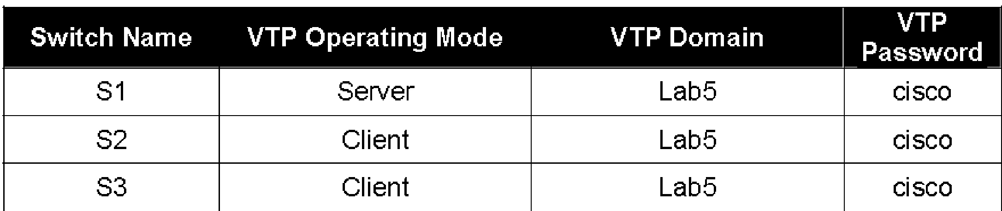

S1(config)#**vtp mode server**

Device mode already VTP SERVER.

S1(config)#**vtp domain Lab6**

Changing VTP domain name from NULL to Lab6

S1(config)#**vtp password cisco**

Setting device VLAN database password to cisco

S1(config)#**end**

S2(config)#**vtp mode client**

Setting device to VTP CLIENT mode

S2(config)#**vtp domain Lab6**

Changing VTP domain name from NULL to Lab6

S2(config)#**vtp password cisco**

Setting device VLAN database password to cisco

S2(config)#**end**

S3(config)#**vtp mode client**

Setting device to VTP CLIENT mode

S3(config)#**vtp domain Lab6**

Changing VTP domain name from NULL to Lab6

S3(config)#**vtp password cisco**

Setting device VLAN database password to cisco

S3(config)#**end**

**Step 3. Configure trunking ports and designate the native VLAN for the trunks.**

Configure Fa0/1 through Fa0/5 as trunking ports, and designate VLAN 99 as the native VLAN for these trunks. When this activity was started, these ports were disabled and must be re-enabled now using the **no shutdown** command.

Only the commands for the FastEthernet0/1 interface on each switch are shown, but the commands should be applied up to the FastEthernet0/5 interface.

S1(config)#**interface fa0/1**

S1(config-if)#**switchport mode trunk**

S1(config-if)#**switchport trunk native vlan 99**

S1(config-I **no shutdown**

f)#S1(config)#**end**

S2(config)#**interface fa0/1**

S2(config-if)#**switchport mode trunk**

S2(config-if)#**switchport trunk native vlan 99**

S2(config-if)#**no shutdown**

S2(config-if)#**end**

S3(config)#**interface fa0/1**

S3(config-if#**switchport mode trunk**

S3(config-if)#**switchport trunk native vlan 99**

S3(config-if)#**no shutdown**

S3(config-if-#**end**

**Step 4. Configure the VTP server with VLANs.**

Configure the following VLANS on the VTP server:

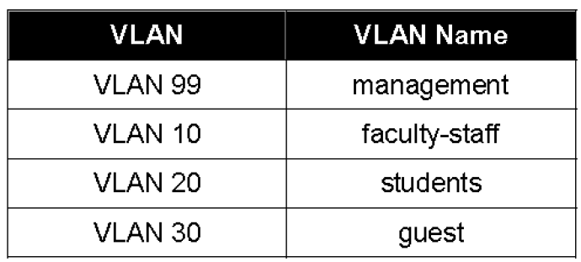

S1(config)#**vlan 99**

S1(config-vlan)#**name management**

S1(config)#**vlan 10**

S1(config-v**name faculty-staff**

lan)#S1(config)#**vlan 20**

S1(config-vlan)#**name students**

S1(config)#**vlan 30**

S1(config-vlan)#**name guest**

S1(config-vlan)#**end**

Verify that the VLANs have been created on S1 with the show vlan brief command.

**Step 5. Verify that the VLANs created on S1 have been distributed to S2 and S3.**

Use the **show vlan brief** command on S2 and S3 to verify that all four VLANs have been distributed to the client switches.

S2#**show vlan brief**

VLAN Name Status Ports

---- ------------------------------ --------- -----------------------------

1 default active Fa0/1, Fa0/2, Fa0/4, Fa0/5

Fa0/6, Fa0/7, Fa0/8, Fa0/9

Fa0/10, Fa0/11, Fa0/12,Fa0/13

Fa0/14, Fa0/15, Fa0/16,Fa0/17

Fa0/18, Fa0/19, Fa0/20,Fa0/21

Fa0/22, Fa0/23, Fa0/24, Gi0/1

Gi0/2

10 faculty/staff active

20 students active

30 guest active

99 management active

S3#**show vlan brief**

VLAN Name Status Ports

---- ---------------------------- --------- -------------------------------

1 default active Fa0/5, Fa0/6, Fa0/7, Fa0/8

Fa0/9, Fa0/10, Fa0/11, Fa0/12

Fa0/13, Fa0/14, Fa0/15, Fa0/16

Fa0/17, Fa0/18, Fa0/19, Fa0/20

Fa0/21, Fa0/22, Fa0/23, Fa0/24

Gig1/1, Gig1/2

10 faculty-staff active

20 students active

30 guest active

99 management active

1002 fddi-default active

1003 token-ring-default active

1004 fddinet-default active

1005 trnet-default active

**Step 6. Configure the management interface address on all three switches.**

S1(config)#**interface vlan99**

S1(config-if)#**ip address 172.17.99.11 255.255.255.0**

S2(config)#**interface vlan99**

S2(config-if)#**ip address 172.17.99.12 255.255.255.0**

S3(config)#**interface vlan99**

S3(config-if)#**ip address 172.17.99.13 255.255.255.0**

Verify that the switches are correctly configured by pinging between them. From S1, ping the management interface on S2 and S3. From S2, ping the management interface on S3.

Were the pings successful? ______________________

If not, troubleshoot the switch configurations and try again.

**Step 7. Assign switch ports to VLANs on S2.**

Port assignments are listed in the table at the beginning of the activity. However, since Packet Tracer 4.11 does not support the **interface range** command, only assign the first port from each range.

S2(config)#**interface fa0/6**

S2(config-if)#**switchport access vlan 30**

S2(config-if)#**interface fa0/11**

S2(config-if)#**switchport access vlan 10**

S2(config-if)#**interface fa0/18**

S2(config-if)#**switchport access vlan 20**

S2(**end**

config-if)# S2#**copy running-config startup-config**

Destination filename [startup-config]? [enter]

Building configuration...

[OK]

S2#

**Step 8. Check connectivity between VLANs.**

Open the Command Prompt on the three PCs.

• Ping from PC1 to PC2 (172.17.20.22)

• Ping from PC2 to PC3 (172.17.30.23)

• Ping from PC3 to PC1 (172.17.30.21)

Are the pings successful? ______________

If not, why do these pings fail?

**Task 4: Configure the Router and the Remote Server LAN**

**Step 1. Create a basic configuration on the router.**

• Configure the router with hostname R1.

• Disable DNS lookup.

• Configure an EXEC mode password of **class**.

• Configure a password of **cisco** for console connections.

• Configure a password of **cisco** for vty connections.

**Step 2. Configure the trunking interface on R1.**

You have demonstrated that connectivity between VLANs requires routing at the network layer, exactly like connectivity between any two remote networks. There are a couple of options for configuring routing between VLANs.

An alternative approach is to create one or more Fast Ethernet connections between the L3 device (the router) and the distribution layer switch, and to configure these connections as **dot1q** trunks. This allows all inter-VLAN traffic to be carried to and from the routing device on a single trunk. However, it requires that the L3 interface be configured with multiple IP addresses. This can be done by creating virtual interfaces, called subinterfaces, on one of the router Fast Ethernet ports and configuring them to be **dot1q** aware.

Using the subinterface configuration approach requires these steps:

• Enter subinterface configuration mode

• Establish trunking encapsulation

• Associate a VLAN with the subinterface

• Assign an IP address from the VLAN to the subinterface

The commands are as follows:

R1(config)#**interface fastethernet 0/0**

R1(config-if)#**no shutdown**

R1(config-if)#**interface fastethernet 0/0.1**

R1(config-subif)#**encapsulation dot1q 1**

R1(config-subif)#**ip address 172.17.1.1 255.255.255.0**

R1(config-subif)#**interface fastethernet 0/0.10**

R1(config-subif)#**encapsulation dot1q 10**

R1(config-subif)#**ip address 172.17.10.1 255.255.255.0**

R1(config-subif)#**interface fastethernet 0/0.20**

R1(config-subif)#**encapsulation dot1q 20**

R1(config-subif)#**ip address 172.17.20.1 255.255.255.0**

R1(config-subif)#**interface fastethernet 0/0.30**

R1(config-subif)#**encapsulation dot1q 30**

R1(config-subif)#**ip address 172.17.30.1 255.255.255.0**

R1(config-subif)#**interface fastethernet 0/0.99**

R1(config-subif)#**encapsulation dot1q 99 native**

R1(config-subif)#**ip address 172.17.99.1 255.255.255.0**

Note the following points in this configuration:

• The physical interface is enabled using the **no shutdown** command, because router interfaces are down by default. The subinterface will then be up by default.

• The subinterface can use any number that can be described with 32 bits, but it is good practice to assign the number of the VLAN as the interface number, as has been done here.

• The native VLAN is specified on the L3 device so that it is consistent with the switches. Otherwise, VLAN 1 is native by default, and there is no communication between the router and the management VLAN on the switches.

**Step 3. Configure the server LAN interface on R1.**

R1(config)#**interface FastEthernet0/1**

R1(config-if)#**ip address 172.17.50.1 255.255.255.0**

R1(config-if)#**description server interface**

R1(config-if)#**no shutdown**

R1(config-if)#**end**

There are now six networks configured. Verify that you can route packets to all six by checking the routing table on R1.

R1#**show ip route**

Gateway of last resort is not set

172.17.0.0/24 is subnetted, 6 subnets

C 172.17.1.0 is directly connected, FastEthernet0/0.1

C 172.17.10.0 is directly connected, FastEthernet0/0.10

C 172.17.20.0 is directly connected, FastEthernet0/0.20

C 172.17.30.0 is directly connected, FastEthernet0/0.30

C 172.17.50.0 is directly connected, FastEthernet0/1

C 172.17.99.0 is directly connected, FastEthernet0/0.99

If your routing table does not show all six networks, troubleshoot your configuration and resolve the problem before proceeding.

**Step 4. Verify Inter-VLAN routing.**

From PC1, verify that you can ping the remote server (172.17.50.254) and the other two hosts (172.17.20.22 and 172.17.30.23). It may take a couple of pings before the end-to-end path is established.

These pings should be successful. If not, troubleshoot your configuration. Check to make sure that the default gateways have been set on all PCs and all switches.

**Practical No.8**

**Cisco MPLS Configuration**

Step 1 – IP addressing of MPLS Core and OSPF

First bring 3 routers into your topology R1, R2, R3 position them as below. We are going to address the routers and configure ospf to ensure loopback to loopback connectivity between R1 and R3.

**Topology –**

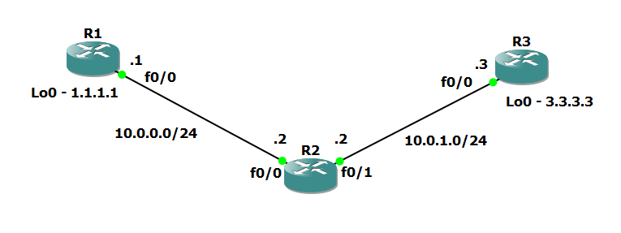

Routers R1 Commands –

R1>Enable

R1(Config)#interface lo0

R1(Config)#hostname R1

R1(Config)#int lo0

R1(Configi-if)#ip add 1.1.1.1 255.255.255.255

R1(Configi-if)#ip ospf 1 area 0

R1(Configi-if)#exit

R1(Config)#int f0/0

R1(Configi-if)#ip add 10.0.0.1 255.255.255.0

R1(Configi-if)#no shut

R1(Configi-if)#ip ospf 1 area 0

R1(Configi-if)#exit

Routers R2 Commands –

R2>Enable

R2(Config)#hostname R2

R2(Config)#int lo0

R2(Configi-if)#ip add 2.2.2.2 255.255.255.255

R2(Configi-if)#ip ospf 1 are 0

R2(Config)#int f0/0

R2(Configi-if)#ip add 10.0.0.2 255.255.255.0

R2(Configi-if)#no shut

R2(Configi-if)#ip ospf 1 area 0

R2(Configi-if)#exit

R2(Config)#int f0/1

R2(Configi-if)#ip add 10.0.1.2 255.255.255.0

R2(Configi-if)#no shut

R2(Configi-if)#ip ospf 1 area 0

R2(Configi-if)#exit

Routers R3 Commands –

R3>Enable

R3(Config)#hostname R3

R3(Config)#int lo0

R3(Configi-if)#ip add 3.3.3.3 255.255.255.255

R3(Configi-if)#ip ospf 1 are 0

R3(Config)#int f0/0

R3(Config-if)#ip add 10.0.1.3 255.255.255.0

R3(Config-if)#no shut

R3(Config-if)#ip ospf 1 area 0

R3(Config-if)#exit

You should now have full ip connectivity between R1, R2, R3 to verify this we need to see if we can ping between the loopbacks of R1 and R3

R1#ping 3.3.3.3 source lo0

Type escape sequence to abort.

Sending 5, 100-byte ICMP Echos to 3.3.3.3, timeout is 2 seconds:

Packet sent with a source address of 1.1.1.1

!!!!!

Success rate is 100 percent (5/5), round-trip min/avg/max = 40/52/64 ms

R1#

You could show the routing table here, but the fact that you can ping between the loopbacks is verification enough and it is safe to move on.

Step 2 – Configure LDP on all the interfaces in the MPLS Core

In order to run MPLS you need to enable it, there are two ways to do this.

* At each interface enter the **mpls ip**command
* Under the ospf process use the **mpls ldp autoconfig**command

For this tutorial we will be using the second option, so go int the ospf process and enter mpls ldp autoconfig – this will enable mpls label distribution protocol on every interface running ospf under that specific process.

R1(Config)#router ospf 1

R1(Config-router)#mpls ldp autoconfig

R2(Config)#router ospf 1

R2(Config-router)#mpls ldp autoconfig

R3(Config)#router ospf 1

R3(Config-router)#mpls ldp autoconfig

You should see log messages coming up showing the LDP neighbors are up.

R2#

*Mar 1 00:31:53.643: %SYS-5-CONFIG_I: Configured from console

*Mar 1 00:31:54.423: %LDP-5-NBRCHG: LDP Neighbor 1.1.1.1:0 (1) is UP

R2#

*Mar 1 00:36:09.951: %LDP-5-NBRCHG: LDP Neighbor 3.3.3.3:0 (2) is UP

To verify the mpls interfaces the command is very simple – **sh mpls interface**  
This is done on R2 and you can see that both interfaces are running mpls and using LDP

R2#sh mpls interface

Interface IP Tunnel Operational

FastEthernet0/0 Yes (ldp) No Yes

FastEthernet0/1 Yes (ldp) No Yes

You can also verify the LDP neighbors with the **sh mpls ldp neighbors** command.

R2#sh mpls ldp neigh

Peer LDP Ident: 1.1.1.1:0; Local LDP Ident 2.2.2.2:0

TCP connection: 1.1.1.1.646 - 2.2.2.2.37909

State: Oper; Msgs sent/rcvd: 16/17; Downstream

Up time: 00:07:46

LDP discovery sources:

FastEthernet0/0, Src IP addr: 10.0.0.1

Addresses bound to peer LDP Ident:

10.0.0.1 1.1.1.1

Peer LDP Ident: 3.3.3.3:0; Local LDP Ident 2.2.2.2:0

TCP connection: 3.3.3.3.22155 - 2.2.2.2.646

State: Oper; Msgs sent/rcvd: 12/11; Downstream

Up time: 00:03:30

LDP discovery sources:

FastEthernet0/1, Src IP addr: 10.0.1.3

Addresses bound to peer LDP Ident:

10.0.1.3 3.3.3.3

One more verification to confirm LDP is running ok is to do a trace between R1 and R3 and verify if you get MPLS Labels show up in the trace.

R1#trace 3.3.3.3

Type escape sequence to abort.

Tracing the route to 3.3.3.3

1 10.0.0.2 [MPLS: Label 17 Exp 0] 84 msec 72 msec 44 msec

2 10.0.1.3 68 msec 60 msec *

As you can see the trace to R2 used an MPLS Label in the path, as this is a very small MPLS core only one label was used as R3 was the final hop.

So to review we have now configured IP addresses on the MPLS core, enabled OSPF and full IP connectivity between all routers and finally enabled mpls on all the interfaces in the core and have established ldp neighbors between all routers.

The next step is to configure MP-BGP between R1 and R3

This is when you start to see the layer 3 vpn configuration come to life.

Step 3 – MPLS BGP Configuration between R1 and R3

We need to establish a Multi Protocol BGP session between R1 and R3 this is done by configuring the vpnv4  address family as below –

R1#

router bgp 1

neighbor 3.3.3.3 remote-as 1

neighbor 3.3.3.3 update-source Loopback0

no auto-summary

!

address-family vpnv4

neighbor 3.3.3.3 activate

R3#

router bgp 1

neighbor 1.1.1.1 remote-as 1

neighbor 1.1.1.1 update-source Loopback0

no auto-summary

!

address-family vpnv4

neighbor 1.1.1.1 activate

*Mar 1 00:45:01.047: %BGP-5-ADJCHANGE: neighbor 1.1.1.1 Up

You should see log messages showing the BGP sessions coming up.

To verify the BGP session between R1 and R3 issue the command **sh bgp vpnv4 unicast all summary**

R1#sh bgp vpnv4 unicast all summary

BGP router identifier 1.1.1.1, local AS number 1

BGP table version is 1, main routing table version 1

Neighbor V AS MsgRcvd MsgSent TblVer InQ OutQ Up/Down State/PfxRcd

3.3.3.3 4 1 218 218 1 0 0 03:17:48 0

You can see here that we do have a bgp vpnv4 peering to R3 – looking at the PfxRcd you can see it says 0 this is because we have not got any routes in BGP. We are now going to add two more routers to the topology. These will be the customer sites connected to R1 and R3. We will then create a VRF on each router and put the interfaces connected to each site router into that VRF.

Step 4 – Add two more routers, create VRFs

We will add two more routers into the topology so it now looks like the final topology

Router 4 will peer OSPF using process number 2 to a VRF configured on R1. It will use the local site addressing of 192.168.1.0/24.

R4

int lo0

ip add 4.4.4.4 255.255.255.255

ip ospf 2 area 2

int f0/0

ip add 192.168.1.4 255.255.255.0

ip ospf 2 area 2

no shut

R1

int f0/1

no shut

ip add 192.168.1.1 255.255.255.0

Now at this point we have R4 peering to R1 but in the global routing table of R1 which is not what we want.

We are now going to start using VRF’s

What is a VRF  in networking?

Virtual routing and forwarding (**VRF**) is a technology included in IP (Internet Protocol) that allows multiple instances of a routing table to co-exist in a router and work together but not interfere with each other.. This increases functionality by allowing network paths to be segmented without using multiple devices.

As an example if R1 was a PE Provider Edge router of an ISP and it had two customers that were both addressed locally with the 192.168.1.0/24 address space it could accommodate both their routing tables in different VRFs – it distinguishes between the two of them using a Route Distinguisher

So back to the topology – we now need to create a VRF on R1

For this mpls tutorial I will be using VRF RED

R1

ip vrf RED

rd 4:4

route-target both 4:4

The RD and route-target do not need to be the same – and for a full explanation please read this post on Route Distinguishers  
[Route Distinguisher vs Route Target](https://www.rogerperkin.co.uk/ccie/mpls/route-distinguisher-vs-route-target/) before proceeding.

So now we have configured the VRF on R1 we need to move the interface F0/1 into that VRF

R1

int f0/1

ip vrf forwarding RED

Now notice what happens when you do that – the IP address is removed

R1(config-if)#ip vrf fo

R1(config-if)#ip vrf forwarding RED

% Interface FastEthernet0/1 IP address 192.168.1.1 removed due to enabling VRF RED

You just need to re-apply it

R1

int f0/1

ip address 192.168.1.1 255.255.255.0

Now if we view the config on R1 int f0/1 you can see the VRF configured.

R1

R1#sh run int f0/1

Building configuration...

Current configuration : 119 bytes

!

interface FastEthernet0/1

ip vrf forwarding RED

ip address 192.168.1.1 255.255.255.0

duplex auto

speed auto

end

R1#

Now we can start to look int VRF’s and how they operate – you need to understand now that there are 2 routing tables within R1

* The Global Routing Table
* The Routing Table for VRF RED

If you issue the command **sh ip route** this shows the routes in the global table and you will notice that you do not see 192.168.1.0/24

R1#sh ip route

Codes: C - connected, S - static, R - RIP, M - mobile, B - BGP

D - EIGRP, EX - EIGRP external, O - OSPF, IA - OSPF inter area

N1 - OSPF NSSA external type 1, N2 - OSPF NSSA external type 2

E1 - OSPF external type 1, E2 - OSPF external type 2

i - IS-IS, su - IS-IS summary, L1 - IS-IS level-1, L2 - IS-IS level-2

ia - IS-IS inter area, * - candidate default, U - per-user static route

o - ODR, P - periodic downloaded static route

Gateway of last resort is not set

1.0.0.0/32 is subnetted, 1 subnets

C 1.1.1.1 is directly connected, Loopback0

2.0.0.0/32 is subnetted, 1 subnets

O 2.2.2.2 [110/11] via 10.0.0.2, 01:03:48, FastEthernet0/0

3.0.0.0/32 is subnetted, 1 subnets

O 3.3.3.3 [110/21] via 10.0.0.2, 01:02:29, FastEthernet0/0

10.0.0.0/24 is subnetted, 2 subnets

C 10.0.0.0 is directly connected, FastEthernet0/0

O 10.0.1.0 [110/20] via 10.0.0.2, 01:02:39, FastEthernet0/0

R1#

If you now issue the command sh ip route vrf red – this will show the routes in the routing table for VRF RED

R1#sh ip route vrf red

% IP routing table red does not exist

**NOTE**: The VRF name is case sensitive!

R1#sh ip route vrf RED

Routing Table: RED

Codes: C - connected, S - static, R - RIP, M - mobile, B - BGP

D - EIGRP, EX - EIGRP external, O - OSPF, IA - OSPF inter area

N1 - OSPF NSSA external type 1, N2 - OSPF NSSA external type 2

E1 - OSPF external type 1, E2 - OSPF external type 2

i - IS-IS, su - IS-IS summary, L1 - IS-IS level-1, L2 - IS-IS level-2

ia - IS-IS inter area, * - candidate default, U - per-user static route

o - ODR, P - periodic downloaded static route

Gateway of last resort is not set

C 192.168.1.0/24 is directly connected, FastEthernet0/1

R1#

We just need to enable OSPF on this interface and get the loopback address for R4 in the VRF RED routing table before proceeding.

R1

int f0/1

ip ospf 2 area 2

You should see a log message showing the OSPF neighbor come up

R1(config-if)#

*Mar 1 01:12:54.323: %OSPF-5-ADJCHG: Process 2, Nbr 4.4.4.4

on FastEthernet0/1 from LOADING to FULL, Loading Done

If we now check the routes in the VRF RED routing table you should see 4.4.4.4 in there as well.

R1#sh ip route vrf RED

Routing Table: RED

Codes: C - connected, S - static, R - RIP, M - mobile, B - BGP

D - EIGRP, EX - EIGRP external, O - OSPF, IA - OSPF inter area

N1 - OSPF NSSA external type 1, N2 - OSPF NSSA external type 2

E1 - OSPF external type 1, E2 - OSPF external type 2

i - IS-IS, su - IS-IS summary, L1 - IS-IS level-1, L2 - IS-IS level-2

ia - IS-IS inter area, * - candidate default, U - per-user static route

o - ODR, P - periodic downloaded static route

Gateway of last resort is not set

4.0.0.0/32 is subnetted, 1 subnets

**O 4.4.4.4 [110/11] via 192.168.1.4, 00:00:22, FastEthernet0/1**

C 192.168.1.0/24 is directly connected, FastEthernet0/1

R1#

We now need to repeat this process for R3 & R6

Router 6 will peer OSPF using process number 2 to a VRF configured on R3. It will use the local site addressing of 192.168.2.0/24.

R6

int lo0

ip add 6.6.6.6 255.255.255.255

ip ospf 2 area 2

int f0/0

ip add 192.168.2.6 255.255.255.0

ip ospf 2 area 2

no shut

R3

int f0/1

no shut

ip add 192.168.2.3 255.255.255.0

We also need to configure a VRF onto R3 as well.

R3

ip vrf RED

rd 4:4

route-target both 4:4

So now we have configured the VRF on R3 we need to move the interface F0/1 into that VRF

R3

int f0/1

ip vrf forwarding RED

Now notice what happens when you do that – the IP address is removed

R3(config-if)#ip vrf forwarding RED

% Interface FastEthernet0/1 IP address 192.168.2.1 removed due to enabling VRF RED

You just need to re-apply it

R3  
int f0/1  
ip address 192.168.2.1 255.255.255.0

Now if we view the config on R3 int f0/1 you can see the VRF configured.

R3

R3#sh run int f0/1

Building configuration...

Current configuration : 119 bytes

!

interface FastEthernet0/1

ip vrf forwarding RED

ip address 192.168.2.1 255.255.255.0

duplex auto

speed auto

end

Finally we just need to enable OSPF on that interface and verify the routes are in the RED routing table.

R3

int f0/1

ip ospf 2 area 2

Check the routes in vrf RED

R3

R3#sh ip route vrf RED

Routing Table: RED

Codes: C - connected, S - static, R - RIP, M - mobile, B - BGP

Gateway of last resort is not set

6.0.0.0/32 is subnetted, 1 subnets

O 6.6.6.6 [110/11] via 192.168.2.6, 00:02:44, FastEthernet0/1

C 192.168.2.0/24 is directly connected, FastEthernet0/1

R3#

Ok so we have come a long way now let’s review the current situation. We now have this setup

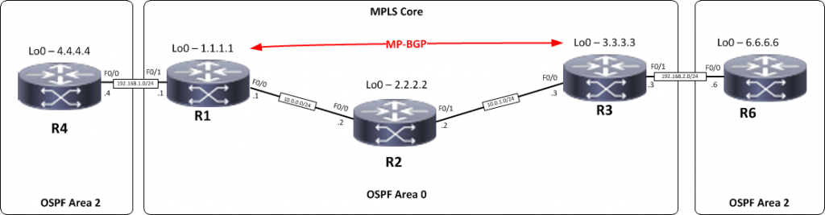

R1,R2,R3 form the MPLS Core and are running OSPF with all loopbacks running a /32 address and all have full connectivity. R1 and R3 are peering with MP-BGP. LDP is enabled on all the internal interfaces. The external interfaces of the MPLS core have been placed into a VRF called RED and then a site router has been joined to that VRF on each side of the MPLS core – (These represent a small office)

The final step to get full connectivity across the MPLS core is to redistribute the routes in OSPF on R1 and R3 into MP-BGP and MP-BGP into OSPF, this is what we are going to do now.